A Comparative Study on the Impact of Capital Structure on Profitability of Ashok Leyland Limited and Bajaj Auto Limited Project Report submitted
in partial fulfilment of the requirements for the award of
MASTERS IN BUSINESS ADMINISTRATION

Submitted by PRASANTH KUMAR S EA2452001011146
Under the guidance of

Dr. Nithya Preetha Pandiarajan., M.Com., M.Phil., B.Ed., Ph.D,
Assistant Professor



SRM Institute of Science and Technology

Kattankulathur

MAY 2026

BONAFIDE CERTIFICATE

Date:

This is to certify that Mr. PRASANTH KUMAR (EA2452001011146) is a Bonafide student of our Institution pursuing final year MASTERS IN BUSINESS ADMINISTRATION during the academic year 2024-2026.
In partial fulfilment of the above-mentioned course the student is required to do a Project work for 2 months and submit the report.

Signature & Seal of Director

ACKNOWLEDGEMENT

I am pleased to acknowledge my sincere thanks to Board of Management of SRM Institute of Science and Technology for their kind encouragement in doing this project and for completing it successfully. I am grateful to them.

I convey my thanks to Dr. Manoranjan Pon. Ram, Director, Directorate of Online Education for providing me necessary support at the right time during the progressive reviews.

I would like to express my sincere and deep sense of gratitude to my Internal Project Guide Dr. Nithya Preetha Pandiarajan, for her constant support and encouragement during the advancement of my project work.

I am extremely grateful to Name of industry guide, for enabling me to work on my project at Company Name and for his valuable guidance, suggestions, and constant encouragement which actually paved way for the successful completion of my Project work.

I wish to express my thanks to all Teaching and Non-teaching staff members of SRMIST, who were helpful in many ways for the completion of my project.

I would like to thank everybody who helped me in submitting my project reportsuccessfully.

Prasanth Kumar S

DECLARATION

I, PRASANTH KUMAR S (EA2452001011146), hereby declare that the Project Report entitled “A Comparative Study on the Impact of Capital Structure on Profitability of Ashok Leyland Limited and Bajaj Auto Limited” was done by me under the guidance of Dr. Nithya Preetha Pandiarajan at the Directorate of Online Education, SRM Institute of Science and Technology, Chennai and submitted in partial fulfilment of the requirements to be awarded the Masters in Business Administration degree.

DATE: 01.05.2026
PLACE: Chennai


Prasanth Kumar S

ABSTRACT

In today’s competitive financial environment, analyzing the relationship between a company’s capital structure and its profitability is essential for investors, management, and other stakeholders. Capital structure decisions, including the mix of debt and equity financing, significantly influence a firm’s financial stability, cost of capital, and overall profitability. This study examines the impact of capital structure on the profitability of Ashok Leyland Limited and Bajaj Auto Limited, two leading Indian companies in the automotive sector.

The primary objective of this study is to evaluate and compare how different capital structures affect profitability using financial ratio analysis. The research focuses on capital structure indicators such as Debt-to-Equity Ratio, Debt Ratio, and Equity Ratio, along with profitability ratios including Net Profit Margin, Return on Assets (ROA), and Return on Equity (ROE). The study is based on secondary data collected from the published annual reports of the companies for the last three financial years (2022–2023 to 2024–2025).

The data is analyzed using comparative financial statements, ratio analysis, and trend analysis techniques to identify patterns, correlations, and the impact of financing decisions on profitability. The findings provide insights into how effectively the selected companies manage their capital structure to enhance profitability and maintain financial stability.

The study concludes by highlighting the strengths and weaknesses in the financial management and capital structure strategies of the selected companies and offers recommendations that can assist investors, financial analysts, and management in making informed strategic and financial decisions.

TABLE OF CONTENTS

S.NO | TOPIC | PAGE NO
1 | INTRODUCTION
1.1 | Introduction | 4
1.2 | Industry Profile | 11
1.3 | Company Profile | 19
1.4 | Problem Statement | 38
1.5 | Objectives of the Study | 42
1.6 | Need for the Study | 43
1.7 | Scope of the Study | 45
1.8 | Limitations of the Study | 46
2 | REVIEW OF LITERATURE
2.1 | Review of Literature | 47
3 | RESEARCH METHODOLOGY
3.1 | Research Design | 50
3.2 | Nature and Source of Data | 50
3.3 | Period of Study | 50
3.4 | Sample Design | 50
3.5 | Variables of the Study | 51
3.6 | Data Collection Method | 51
3.7 | Analytical Framework | 51
3.8 | Hypothesis of the Study | 52
3.9 | Tools and Software Used | 52
3.10 | Statistical Tools Proposed To Be Used | 52
4 | ANALYSIS AND INTERPRETATION
4.1 | Percentage Analysis | 56
4.2 | Correlation | 57
4.4 | ANOVA | 59
5 | FINDINGS AND CONCLUSION
5.1 | Findings | 67
5.2 | Suggestions | 69
5.3 | Conclusion | 71
 | BIBLIOGRAPHY
 | Reference | 73

LIST OF TABLES

TABLE NO | PARTICULARS | PAGE NO
4.1 | Capital Structure Ratios of Ashok Leyland Limited (2022–2025) | 57
4.2 | Capital Structure Ratios of Bajaj Auto Limited (2022–2025) | 57
4.3 | Profitability Ratios of Ashok Leyland Limited (2022–2025) | 59
4.4 | Profitability Ratios of Bajaj Auto Limited (2022–2025) | 60
4.5 | Comparative Summary of Capital Structure and Profitability (2024–2025) | 63
4.6 | Correlation between Capital Structure and Profitability | 64
4.7 | ANOVA Results for Profitability between Selected Companies | 66

LIST OF CHARTS

FIG.NO | PARTICULARS | PAGE NO
4.1 | Debt–Equity Ratio (2022–2025) | 57
4.2 | Debt Ratio (2022–2025) | 58
4.3 | Equity Ratio (2022–2025) | 58
4.4 | Profitability Ratios of Ashok Leyland Limited (2022–2025) | 59
4.5 | Net Profit Margin (%) (2022–2025) | 61
4.6 | Return on Assets (ROA %) (2022–2025) | 62
4.7 | Return on Equity (ROE %) (2022–2025) | 62
4.8 | Comparative Summary of Capital Structure and Profitability (2024–2025) | 63
4.9 | Correlation between Capital Structure and Profitability | 64
4.10 | One-way ANOVA – F Value Comparison | 65

“A Comparative Study on the Impact of Capital Structure on Profitability of Ashok Leyland Limited and Bajaj Auto Limited”

CHAPTER – 1

INTRODUCTION:

In the modern business environment, financial management plays a decisive role in determining the success, stability, and growth of an organization. With increasing competition, globalization, fluctuations in economic conditions, and rapid technological changes, companies are required to make effective financial decisions to survive and grow in the long run. Among the various financial decisions, capital structure decisions are considered one of the most critical, as they directly influence a firm’s profitability, cost of capital, risk, and overall financial performance. The relationship between capital structure and profitability has therefore emerged as an important area of study in the field of corporate finance.

Capital structure refers to the combination of long-term sources of funds employed by a company to finance its assets and operations. These sources generally include equity capital, preference capital, retained earnings, debentures, and long-term borrowings. Every firm must decide the proportion of debt and equity in its capital structure in such a way that it maximizes shareholder wealth and minimizes financial risk. A sound capital structure ensures financial stability, improves operational efficiency, and enhances the firm’s ability to withstand adverse economic conditions. On the other hand, an inappropriate capital structure can lead to excessive financial burden, increased cost of capital, and reduced profitability.

Profitability is one of the most important objectives of any business enterprise, as it ensures long-term survival and growth. It reflects the efficiency with which a company utilizes its resources to generate income.

Higher profitability improves investor confidence, strengthens the company’s
financial position, and enables internal financing of future growth. Profitability also

serves as a key indicator of managerial efficiency, operational performance, and competitive strength. Therefore, understanding the factors influencing profitability, particularly the role played by capital structure, is crucial for both management and investors.

The relationship between capital structure and profitability has been widely debated in financial theories and empirical studies. According to financial leverage theory, the use of debt can increase returns to equity shareholders due to the fixed nature of interest payments and tax benefits associated with debt. This can improve profitability as long as the firm earns more than the cost of debt. However, excessive use of debt increases financial risk and interest obligations, which may negatively affect profits during periods of low earnings or economic downturns. Hence, an optimal capital structure is essential to balance risk and return effectively.

To analyze capital structure, financial ratios such as Debt-Equity Ratio, Debt Ratio, and Equity Ratio are commonly used. These ratios indicate the extent to which a company depends on debt financing and assess its long-term solvency position. A higher debt-equity ratio signifies greater financial leverage, while a lower ratio reflects a conservative financing policy. Profitability is measured using ratios such as Net Profit Margin, Return on Assets (ROA), and Return on Equity (ROE), which evaluate earning efficiency relative to sales, assets, and shareholders’ funds. Studying the relationship between these ratios helps in understanding how financing decisions affect profitability.

The automotive industry is one of the most significant sectors of the Indian economy, contributing substantially to industrial growth, employment generation, and exports. The industry is capital-intensive in nature and requires substantial investment in plant and machinery, technology upgradation, research and development, and supply chain infrastructure. Due to high capital requirements, companies in the automotive sector often rely on a mix of internal and external financing sources. As a result, capital structure decisions play a vital role in determining their financial performance and profitability.

This study focuses on two major companies in the Indian automotive industry, namely Ashok Leyland Limited and Bajaj Auto Limited. Ashok Leyland Limited is a leading manufacturer of commercial vehicles and operates in a segment that demands heavy capital investment. The company’s financing pattern generally includes a higher proportion of debt to support its large-scale manufacturing operations. Bajaj Auto Limited is one of the largest manufacturers of two-wheelers and three-wheelers in India and has maintained a relatively strong financial position with limited dependence on borrowed funds. These two companies follow different capital structure strategies, making them suitable for a comparative study.

The present study aims to analyze the impact of capital structure on the profitability of Ashok Leyland Limited and Bajaj Auto Limited over a period of three financial years from 2022–2023 to 2024–2025. By examining recent financial data, the study seeks to provide a realistic assessment of how capital structure decisions influence profitability under current economic and industry conditions. A comparative approach helps in evaluating the financial performance of both companies and understanding the effectiveness of their respective financing strategies.

The study is based on secondary data collected from the published annual reports and financial statements of the selected companies. Comparative ratio analysis has been used as the primary analytical tool to evaluate capital structure and profitability. This method enables systematic comparison of financial performance, identification of trends, and assessment of relative strengths and weaknesses of the companies. Such analysis is valuable for investors, financial analysts, and management in making informed decisions.

In addition to financial ratios, the study also considers the influence of internal management policies, business strategies, and external economic factors on capital structure and profitability. Factors such as market competition, demand conditions, interest rate fluctuations, inflation, and government regulations can significantly impact a company’s financing decisions and profit levels. Understanding these factors provides a comprehensive perspective of the relationship between capital structure and profitability.

INDUSTRY PROFILE:

Introduction:

The automobile industry is one of the most vital and high-impact sectors contributing to industrial growth and economic development in both developed and developing economies. The industry plays a crucial role in facilitating mobility of people and goods, supporting trade, commerce, logistics, and industrial productivity. Automobiles have become an integral part of modern economic life by enabling efficient transportation, promoting regional integration, and enhancing access to markets, services, and employment opportunities. As a result, the automobile industry serves as a significant engine of economic growth, technological advancement, and employment generation.

The automobile industry encompasses a wide range of activities, including the design, manufacturing, marketing, and servicing of vehicles such as two-wheelers, three-wheelers, passenger vehicles, light commercial vehicles, medium and heavy commercial vehicles, tractors, and specialized vehicles. In addition, the industry includes a large network of auto component manufacturers, ancillary suppliers, logistics providers, dealers, and service centers. This extensive ecosystem creates strong forward and backward linkages with several allied industries such as steel, aluminum, rubber, plastics, electronics, glass, petroleum products, and financial services.

From a financial perspective, the automobile industry is capital-intensive and technologically evolving. Automobile manufacturers are required to make continuous investments in plant and machinery, automation, research and development, emission-control technology, safety systems, and digital platforms. These characteristics make financial management, especially capital structure decisions, critically important. The mix of debt and equity employed by automobile firms significantly influences their profitability, liquidity, risk profile, and long-term sustainability. Therefore, understanding the nature and financial dynamics of the

automobile industry is essential for analyzing the impact of capital structure on profitability.

Meaning and Definition of Automobile Industry

The automobile industry refers to the sector engaged in the production, assembly, distribution, and servicing of motor vehicles designed for transportation of passengers and goods. It includes manufacturers of vehicles powered by internal combustion engines as well as electric and alternative energy-based systems. The industry also comprises auto component and ancillary industries that supply essential parts, systems, and sub-assemblies required for vehicle production.

The automobile industry is often described as a core or foundation industry due to its extensive integration with industrial manufacturing, infrastructure development, and service sectors. Its growth has a multiplier effect on employment, income, technological capability, and overall economic activity.

Key Attributes of the Automobile Industry

The automobile industry exhibits distinctive attributes that differentiate it from other manufacturing sectors. It is characterized by high levels of capital investment, long development cycles, strong dependence on technology, significant research and development expenditure, high fixed costs, and complex regulatory compliance requirements. The industry is highly competitive, with domestic and global players competing on price, quality, technology, efficiency, and brand reputation. Demand patterns are influenced by macroeconomic conditions, income levels, availability of finance, fuel prices, and infrastructure growth.

Nature and Characteristics of the Automobile Industry

The automobile industry operates under unique structural and operational conditions that have a direct bearing on financial performance and capital structure decisions.

The industry is capital-intensive in nature, requiring heavy investment in facilities, machinery, tooling, robotics, and quality control systems. Once installed, these assets involve high fixed costs, making capacity utilization a critical determinant of profitability. Automobile manufacturing also involves long product development cycles, often spanning several years, during which companies incur substantial design, testing, and homologation expenses.

Technological innovation plays a central role in the industry. Continuous advancements in engine technology, safety systems, digital connectivity, and alternative fuels compel firms to invest heavily in research and development. These investments are typically long-term and involve uncertainty, thereby influencing financing decisions.

The industry is also cyclical, with demand closely linked to economic growth, interest rates, fuel prices, and consumer sentiment. During economic expansions, vehicle sales increase, improving profitability and cash flows. Conversely, economic slowdowns result in reduced demand, excess capacity, and pressure on margins. Under such conditions, firms with high debt levels face increased financial stress, highlighting the importance of optimal capital structure planning.

Historical Evolution of the Automobile Industry

Globally, the automobile industry evolved through several stages, beginning with the invention of the internal combustion engine and early handcrafted vehicles. The introduction of mass production techniques, particularly the assembly line system, revolutionized automobile manufacturing by significantly reducing costs and increasing output. Over time, the industry expanded globally, with manufacturers establishing production facilities across multiple countries to serve regional markets.

Technological progress led to improvements in fuel efficiency, safety features, comfort, and reliability. In recent decades, heightened environmental concerns and regulatory pressures have accelerated the development of cleaner technologies, including electric vehicles, hybrid systems, and alternative fuels.

In India, the automobile industry evolved from a highly regulated and protected sector before economic liberalization to a competitive and globally integrated industry. Prior to 1991, the industry was characterized by limited competition, low production volumes, and outdated technology. Economic liberalization opened the sector to foreign investment, leading to increased competition, technological modernization, and capacity expansion.

Subsequent periods witnessed rapid growth driven by rising incomes, urbanization, improved road infrastructure, and increased availability of vehicle financing. In recent years, the industry has undergone further transformation due to stricter emission norms, digitalization, and the gradual shift towards electric mobility.

Structure of the Indian Automobile Industry

The Indian automobile industry comprises several segments, each with distinct characteristics and financial requirements.

The two-wheeler segment constitutes the largest share in terms of volume and caters primarily to personal mobility needs. It is characterized by relatively lower capital intensity, faster inventory turnover, and strong export potential. The three-wheeler segment serves passenger transport and last-mile cargo movement, especially in urban and semi-urban areas.

The passenger vehicle segment includes cars and utility vehicles, which are highly competitive and feature-driven. This segment requires continuous investment in design, marketing, and technology upgrades. The commercial vehicle segment encompasses light, medium, and heavy vehicles used for logistics and public transportation. This segment is highly capital-intensive and cyclical, with demand closely linked to economic activity and infrastructure development.

Automobile Industry Market Overview

At the global level, the automobile industry remains one of the largest manufacturing sectors. Growth is driven by urbanization, industrial expansion, logistics demand, and technological innovation. Emerging economies have become major growth centers due to rising population, income growth, and demand for mobility.

In India, the automobile industry is among the largest in the world, particularly in two-wheelers and commercial vehicles. Growth drivers include rising disposable income, improving road infrastructure, government initiatives supporting manufacturing, export opportunities, and increasing demand for personal and commercial transportation.

Supply Chain Structure of the Automobile Industry

The automobile supply chain is complex and multi-layered, involving raw material suppliers, component manufacturers, original equipment manufacturers, logistics providers, dealers, and customers. Efficient coordination across the supply chain is essential to control costs, minimize production disruptions, and improve working capital efficiency.

Automobile manufacturers rely on just-in-time inventory practices to reduce holding costs and improve operational efficiency. However, supply chain disruptions can significantly impact production schedules and profitability, emphasizing the need for strong supplier relationships and robust risk management.

Distribution and Dealer Network

The dealer network plays a crucial role in the automobile industry by acting as the interface between manufacturers and customers. Dealers manage vehicle inventory, sales, financing support, and after-sales services. Dealer inventory financing and receivables directly affect manufacturers’ cash flows and financial performance.
A strong and efficient dealer network enhances market reach, brand visibility, and customer satisfaction. However, extended credit terms and higher dealer incentives can increase working capital requirements for manufacturers.

Role of Rural and Urban Markets

Urban markets dominate passenger vehicle demand due to higher income levels, better infrastructure, and increased preference for personal mobility. Rural markets are particularly important for two-wheelers, tractors, and entry-level vehicles. Demand in rural areas is influenced by agricultural income, monsoon conditions, and government support programs.

Rural demand also tends to be seasonal, requiring careful inventory planning and financing strategies. Manufacturers must balance urban and rural market dynamics to optimize production and profitability.

Competitive Landscape of the Automobile Industry

The automobile industry is highly competitive, with numerous domestic and international players operating across segments. Competition is based on price, product features, technological innovation, fuel efficiency, brand reputation, and after-sales service quality.

High competition places pressure on margins and compels firms to focus on cost control, efficiency improvement, and differentiation strategies. Capital structure decisions influence a firm’s ability to invest in innovation, marketing, and capacity expansion, thereby affecting its competitive position.

Porter’s Five Forces Analysis

The threat of new entrants in the automobile industry is moderate due to high capital requirements, technological expertise, and regulatory compliance costs. However, new entrants are emerging in the electric vehicle segment.
The bargaining power of suppliers is moderate, as manufacturers rely on specialized components but large firms can negotiate favorable terms. The bargaining power of buyers is high due to the availability of multiple alternatives and price sensitivity.

The threat of substitutes is moderate, with public transport, ride-sharing, and alternative mobility solutions posing competition. Competitive rivalry is very high due to intense competition among established firms.

PESTLE Analysis

Political factors such as government policies on emission norms, safety regulations, and infrastructure development significantly influence the industry. Economic factors including interest rates, fuel prices, inflation, and income levels affect demand and profitability.

Social factors such as lifestyle changes, urbanization, and safety awareness influence vehicle preferences. Technological factors include advancements in electric mobility, automation, and digital connectivity. Legal factors relate to compliance with environmental and safety standards. Environmental factors emphasize sustainability, emission reduction, and green manufacturing.

Capital Structure Characteristics of the Automobile Industry

Capital structure decisions are crucial in the automobile industry due to high capital requirements and cyclical demand. Firms use a mix of equity, retained earnings, and long-term debt to finance operations and investments. Commercial vehicle manufacturers often carry higher leverage due to asset intensity, while two-wheeler manufacturers usually maintain conservative capital structures supported by strong internal cash generation.

Impact of Capital Structure on Profitability

Capital structure directly affects profitability through financing costs and risk exposure. Moderate leverage can enhance return on equity during favorable conditions, while excessive debt increases financial risk and interest burden.

Automobile firms must balance leverage to optimize profitability without compromising financial stability.

Industry Challenges and Risk Factors

The industry faces challenges such as demand volatility, rising input costs, regulatory pressures, technological disruption, and intense competition. Financial risk is amplified by high fixed costs and leverage, making prudent capital structure management essential.

Industry Outlook and Future Trends

The automobile industry is undergoing transformation driven by electric mobility, digitalization, and sustainability initiatives. Future growth will depend on technological adaptation, financial resilience, and effective capital allocation.

Relevance of Industry Profile to the Present Study

A comprehensive understanding of the automobile industry provides a necessary foundation for analyzing how capital structure impacts profitability. Differences in segment characteristics justify a comparative study of Ashok Leyland Limited and Bajaj Auto Limited.

COMPANY PROFILE:




Ashok Leyland Limited and Bajaj Auto Limited are two of India’s most prominent automotive manufacturers, each representing distinct segments of the automobile industry while contributing significantly to the country’s industrial and economic development. Both companies have long operational legacies, strong brand recognition, and established leadership positions within their respective markets. Their business models, capital requirements, and profitability dynamics differ substantially due to variations in product categories, customer bases, and operating environments, making them particularly suitable for a comparative financial study.

Ashok Leyland Limited is one of India’s leading manufacturers of commercial vehicles, with a strong presence in medium and heavy trucks, buses, and specialized vehicles. The company operates in a capital-intensive and cyclical segment where investments in plant, machinery, and technology play a major role in determining profitability and financial stability. Ashok Leyland is part of the Hinduja Group, a diversified global conglomerate, and has been closely associated with India’s transportation and logistics development for several decades.

Bajaj Auto Limited, on the other hand, is one of India’s largest and most globally recognized manufacturers of two-wheelers and three-wheelers. The company has built a strong reputation for product performance, export leadership, and disciplined financial management. Bajaj Auto operates in a relatively high-volume, faster-turnover segment of the automobile industry and is widely known for maintaining a conservative capital structure supported by strong internal cash generation.

Together, Ashok Leyland and Bajaj Auto offer contrasting but complementary perspectives on how capital structure decisions influence profitability in the automobile sector. This merged company profile provides a detailed understanding of their background, operations, business models, and strategic orientation, forming a strong foundation for the comparative analysis undertaken in this study.

Company Overview

Ashok Leyland Limited is headquartered in Chennai, Tamil Nadu, and is listed on India’s major stock exchanges, including the Bombay Stock Exchange (BSE) and the National Stock Exchange (NSE). The company is recognized as one of the largest manufacturers of commercial vehicles in India and has a growing presence in select international markets. Its association with the Hinduja Group provides financial backing, governance structure, and strategic direction aligned with long-term growth objectives.

Bajaj Auto Limited is headquartered in Pune, Maharashtra, and is also listed on the BSE and NSE. The company is a flagship entity of the Bajaj Group and is widely regarded as one of the most profitable automobile manufacturers in India. Bajaj Auto enjoys strong brand equity both in domestic and international markets and derives a significant share of its revenues from exports, particularly in emerging economies.

Both companies are part of major market indices and are actively tracked by investors, analysts, and financial institutions. Their scale of operations, financial transparency, and market leadership make them suitable subjects for academic and financial analysis.

Corporate Philosophy and Strategic Orientation

Ashok Leyland’s corporate philosophy emphasizes that commercial mobility solutions must support economic development while ensuring safety, reliability, and sustainability.

The company’s strategic orientation reflects a long-term commitment to building durable products tailored to Indian operating conditions, such as varied road quality, load requirements, and cost sensitivity. Ashok Leyland places strong emphasis on engineering excellence, fleet-centric solutions, and lifecycle cost optimization for customers.

Bajaj Auto’s corporate philosophy is centered on performance, innovation, and efficiency. The company emphasizes value creation through product differentiation, cost leadership, and disciplined capital allocation. Bajaj Auto has consistently communicated that shareholder returns, operational productivity, and global competitiveness are core strategic priorities. Its philosophy reflects a belief in financial self-reliance, minimal dependence on external borrowing, and robust free cash flow generation.

The contrast between Ashok Leyland’s infrastructure-oriented, asset-heavy philosophy and Bajaj Auto’s volume-driven, efficiency-oriented philosophy creates a meaningful context for analyzing differences in capital structure and profitability.

Historical Background and Evolution

Ashok Leyland Limited traces its origins to the late 1940s and has evolved alongside India’s post-independence industrial and infrastructure development. Initially focused on vehicle assembly, the company gradually expanded its manufacturing capabilities, technology base, and product range. Over time, Ashok Leyland became a key supplier of commercial vehicles for public transport systems, logistics operators, and government institutions. The company’s evolution reflects steady capacity expansion, localization of technology, and adaptation to changing regulatory and market requirements.

Bajaj Auto Limited has its roots in the broader Bajaj Group, which was established in the early twentieth century. Bajaj Auto emerged as a dedicated automobile manufacturing entity and gained prominence through its focus on scooters and later motorcycles.

The company’s growth trajectory was influenced by rising demand for affordable personal mobility and later by international expansion. Bajaj Auto has progressively repositioned itself as a performance-driven motorcycle manufacturer and a global exporter, particularly to markets in Asia, Africa, and Latin America.

The historical paths of both companies highlight different growth drivers—Ashok Leyland’s dependence on infrastructure and freight demand versus Bajaj Auto’s link to consumer mobility and exports.

Nature of Business and Business Model

Ashok Leyland operates primarily as a commercial vehicle manufacturer, serving customers such as fleet operators, transport corporations, logistics companies, and defense organizations. Its business model involves high upfront capital investment, long asset life cycles, and relatively longer sales and replacement cycles. Profitability is influenced by capacity utilization, order flows, and economic conditions, making financial planning and capital structure management critical.

Bajaj Auto’s business model is based on high-volume manufacturing and rapid sales turnover. The company focuses on standardized platforms, scalable production, and strong distribution reach. Bajaj Auto benefits from faster inventory movement, predictable demand patterns, and strong export revenues. These characteristics support higher operating margins and enable the company to operate with a leaner balance sheet and minimal long-term debt.

The difference in business models directly affects working capital needs, financing strategies, and profitability outcomes for both firms.

Business Segments and Product Orientation

Ashok Leyland’s operations are organized around commercial vehicles, including trucks, buses, light commercial vehicles, and specialized vehicles. In addition, the company is engaged in defense mobility solutions and power solutions. Each segment requires customized engineering, regulatory compliance, and significant capital investment in manufacturing and testing infrastructure.

Bajaj Auto’s business is organized around two-wheelers and three-wheelers, with products designed for both domestic and export markets. The company’s portfolio is segmented by engine capacity, price positioning, and performance characteristics. This segmentation allows Bajaj Auto to serve multiple customer groups while maintaining efficiency through platform sharing and component commonality.

Market Presence and Customer Base

Ashok Leyland serves a predominantly institutional and fleet-oriented customer base, with demand influenced by freight movement, public transport requirements, and government spending on infrastructure. The company’s sales are closely tied to economic cycles, making revenue streams more volatile.

Bajaj Auto serves a broad consumer base, including individual riders, small business owners, and commercial users of three-wheelers. Its export markets further diversify demand, reducing dependence on any single geography. This diversified customer base provides relatively stable revenue streams.

Relevance to Capital Structure and Profitability Analysis

The contrasting operational and financial characteristics of Ashok Leyland Limited and Bajaj Auto Limited make them particularly relevant for a comparative study on the impact of capital structure on profitability.
Ashok Leyland’s capital-intensive operations necessitate a more leveraged financing structure, exposing profitability to interest costs and economic cycles. Bajaj Auto’s

strong internal cash generation allows it to maintain low leverage, leading to greater financial stability and consistent profitability.

Understanding these foundational differences is essential before undertaking ratio analysis and comparative financial evaluation in subsequent chapters.

Manufacturing Footprint and Operational Infrastructure

Ashok Leyland Limited operates a broad manufacturing footprint designed to support large-scale production of commercial vehicles and related mobility solutions. The company has established manufacturing facilities across multiple regions in India, allowing it to serve geographically diverse markets while reducing logistics costs and improving delivery efficiency. These facilities are equipped to manufacture chassis, engines, aggregates, and fully built vehicles that meet both domestic regulatory standards and customer-specific requirements. Because commercial vehicle manufacturing involves higher payloads, durability standards, and compliance requirements, Ashok Leyland’s plants are characterized by heavy capital investment in machinery, fabrication lines, testing equipment, and quality control systems.

The company’s manufacturing operations emphasize flexibility to handle different vehicle configurations and batch sizes. Fleet customers often demand customized specifications based on load conditions, operating terrain, and fuel efficiency requirements. This customization capability increases engineering complexity and working capital requirements, as component inventories must be planned carefully to avoid production delays or cost overruns. Ashok Leyland’s manufacturing model therefore relies not only on physical infrastructure but also on robust production planning and vendor coordination.

Bajaj Auto Limited’s manufacturing infrastructure reflects a different operational philosophy, aligned with high-volume, standardized production. The company operates large, highly automated manufacturing plants focused on motorcycles and three-wheelers. Bajaj Auto’s plants are designed for scale, efficiency, and consistency, enabling the company to produce millions of units annually with relatively lower per-unit fixed cost. Advanced automation, standardized platforms,

and modular design principles help Bajaj Auto achieve productivity advantages and cost leadership.

Unlike commercial vehicle manufacturing, two-wheeler and three-wheeler production allows for faster throughput and more predictable scheduling. This operational characteristic reduces inventory holding periods and supports quicker cash conversion. Bajaj Auto’s manufacturing model, therefore, directly contributes to its strong profitability and ability to operate with limited reliance on external debt financing.

Supply Chain and Procurement Strategy

Ashok Leyland’s supply chain is complex and multi-layered, involving a vast network of component suppliers, logistics providers, and service partners. The manufacturing of commercial vehicles requires sourcing of heavy components such as engines, axles, transmissions, frames, and specialized body parts. Managing supplier quality, delivery schedules, and cost efficiency is critical, as delays or disruptions can significantly impact production timelines and customer commitments.

Given the capital-intensive nature of its operations, Ashok Leyland must balance inventory availability with cost control. Excess inventory can lock capital and affect liquidity, while insufficient inventory can disrupt production and erode customer trust. As a result, supply chain efficiency plays a central role in managing working capital and profitability.

Bajaj Auto’s supply chain, while also extensive, benefits from higher standardization of components and economies of scale in procurement. The company leverages its large production volumes to negotiate favorable terms with suppliers, improving cost efficiency and payment conditions. Because motorcycle and three-wheeler components are typically lighter and more modular, inventory management is less capital-intensive compared to commercial vehicles.
The relative simplicity and predictability of Bajaj Auto’s supply chain support shorter inventory cycles and contribute to its strong cash flow position. This operational

advantage strengthens the company’s balance sheet and reduces dependence on short-term borrowing.

Research, Development, and Technological Orientation

Ashok Leyland’s research and development activities are closely aligned with regulatory compliance, durability enhancement, and operating cost optimization. The company invests significantly in developing engines that comply with emission norms, improving vehicle safety features, and enhancing fuel efficiency under real-world operating conditions. R&D also focuses on alternative fuels, electric mobility solutions for public transport, and defense-grade vehicle technologies.

Such R&D investments are long-term in nature and require substantial capital commitment with uncertain payback periods. These investments influence Ashok Leyland’s asset base and financing decisions, as returns on R&D are realized gradually through improved product acceptance and regulatory compliance.

Bajaj Auto’s R&D orientation emphasizes product performance, styling, engine refinement, and adaptation to global regulations. Innovation at Bajaj Auto is driven by consumer preferences, competitive positioning, and export market requirements. Faster product development cycles and clear market feedback allow Bajaj Auto to manage R&D investment risk more effectively.

The R&D strategies of both companies directly influence capital allocation, cost structures, and long-term profitability, reinforcing the relevance of capital structure analysis.

Marketing Strategy and Brand Positioning

Ashok Leyland’s marketing approach is largely business-to-business oriented, with emphasis on relationships with fleet operators, transport corporations, and institutional buyers.
The company’s brand positioning focuses on reliability, total cost of ownership, and service support. Sales decisions are influenced by operating economics rather than

emotional brand appeal, making after-sales service and lifecycle cost management critical success factors.

Marketing expenditures for Ashok Leyland are therefore oriented toward dealer capabilities, service infrastructure, and customer engagement at an institutional level. These efforts support revenue stability but also require sustained investment, affecting cash flows and profitability.

Bajaj Auto’s marketing strategy is consumer-centric and brand-driven. The company invests heavily in brand communication, product launches, and performance positioning, particularly for its motorcycle portfolio. Strong brand equity enables Bajaj Auto to command pricing power, improve sales volumes, and maintain high inventory turnover.

Effective marketing at Bajaj Auto directly supports faster sales conversion, improved dealer confidence, and predictable demand patterns, all of which enhance working capital efficiency and profitability.

Distribution Network and Route to Market

Ashok Leyland’s distribution network consists of authorized dealers, service centers, and parts distributors spread across urban and rural markets. Commercial vehicle sales often involve credit arrangements, extended negotiation, and customization, resulting in longer receivables cycles compared to consumer vehicles. Managing dealer credit, financing support, and inventory levels is therefore central to Ashok Leyland’s working capital strategy.

Bajaj Auto’s distribution network is wider in terms of retail presence and benefits from standardized dealer models and faster retail sales. Two-wheeler sales typically involve quicker transactions and faster realization of revenues. In export markets, Bajaj Auto works through distributors and partners, diversifying credit risk across geographies.
The efficiency of Bajaj Auto’s distribution system supports strong liquidity and lower receivables risk.

Human Resources and Organizational Culture

Ashok Leyland employs a large workforce spread across manufacturing plants, R&D centers, and sales offices. Managing human resources in a capital-intensive, manufacturing-focused organization requires structured training, safety compliance, and industrial relations management. Workforce stability and skill development play a significant role in production continuity and quality outcomes.

Bajaj Auto’s organizational culture emphasizes productivity, performance accountability, and innovation. The company operates with a relatively lean workforce supported by automation and efficient processes. This cultural orientation contributes to higher output per employee and sustained profitability.

Financial Structure and Capital Allocation

Ashok Leyland’s financial structure reflects its asset-heavy operations and cyclical revenue patterns. The company relies on a mix of equity, retained earnings, and long-term debt to finance capital expenditure and working capital needs. Interest costs form a meaningful component of expenses, making profitability sensitive to leverage levels and economic conditions.

Bajaj Auto’s financial structure is characterized by strong internal cash generation and minimal reliance on long-term borrowing. The company often maintains surplus cash and investments on its balance sheet, providing financial flexibility and stability. This conservative capital structure enhances return on equity and reduces financial risk.

Profitability Patterns and Business Risk
Ashok Leyland’s profitability fluctuates with demand cycles, infrastructure spending, and freight movement. High fixed costs magnify the impact of volume changes on operating margins. During downturns, interest obligations can exert pressure on net profits.

Bajaj Auto’s profitability is more stable due to diversified markets, strong exports, and efficient cost management. Lower financial leverage reduces earnings volatility and supports consistent shareholder returns.

Strategic Fit with the Present Study

The contrasting financial and operational characteristics of Ashok Leyland Limited and Bajaj Auto Limited provide an ideal framework for examining the impact of capital structure on profitability. Differences in leverage, asset intensity, and working capital behavior create measurable financial outcomes that can be analyzed using ratio analysis and comparative techniques.

Corporate Social Responsibility and Sustainability Orientation

Ashok Leyland Limited recognizes that commercial vehicle manufacturing has a direct impact on society through transportation safety, environmental footprint, and workforce engagement. The company integrates corporate social responsibility into its business philosophy, focusing on road safety awareness, skill development, education, healthcare, and community development in regions surrounding its manufacturing facilities. CSR initiatives are aligned with statutory requirements and are implemented through structured programs with measurable social outcomes.

Sustainability has become an increasingly important component of Ashok Leyland’s long-term strategy. The company invests in emission-compliant vehicle technologies, energy-efficient manufacturing processes, water stewardship initiatives, and waste reduction programs.
Given the heavy nature of commercial vehicles and their environmental impact, regulatory compliance and sustainability investments are essential for long-term operational continuity. These initiatives require continuous capital allocation and influence cost structures, yet they also reduce regulatory risk and strengthen long-term brand credibility.

Bajaj Auto Limited likewise views corporate responsibility as an integral part of its corporate identity. The company undertakes CSR initiatives focused on education,

healthcare, skill development, and community upliftment, particularly in areas where its manufacturing facilities are located. Bajaj Auto’s CSR philosophy emphasizes measurable outcomes and long-term societal benefits rather than short-term philanthropic gestures.
From a sustainability perspective, Bajaj Auto focuses on cleaner engine technologies, fuel efficiency, and compliance with global emission norms across domestic and export markets. The company’s relatively lighter product portfolio allows it to achieve sustainability goals with lower capital intensity compared to heavy commercial vehicles. These efforts not only enhance regulatory compliance but also align with evolving consumer preferences for environmentally responsible mobility solutions.

Corporate Governance Framework and Ethical Standards

Ashok Leyland Limited operates within a structured corporate governance framework that includes a professionally constituted Board of Directors, audit committees, risk management committees, and compliance oversight mechanisms. As a listed entity, the company adheres to statutory governance requirements while aligning with best practices prescribed by regulators and industry bodies. Transparent disclosure practices, internal audits, and risk management systems form the foundation of Ashok Leyland’s governance structure.

The company’s governance framework is particularly important because of its scale of operations, capital-intensive nature, and reliance on external financing.

Effective governance ensures prudent capital allocation, oversight of leverage, and alignment between management strategies and shareholder interests. Ethical conduct, compliance, and accountability play a key role in maintaining investor confidence and long-term financial stability.

Bajaj Auto Limited is widely recognized for its strong corporate governance and conservative financial philosophy. The company maintains a well-structured board with independent oversight and emphasizes transparency, ethical conduct, and disciplined decision-making. Bajaj Auto’s governance practices reflect a strong focus on shareholder value, capital discipline, and risk containment.

The company’s conservative approach to borrowing and surplus cash management reflects governance values that prioritize financial resilience and long-term sustainability. Strong governance allows Bajaj Auto to maintain operational autonomy, respond effectively to market changes, and sustain profitability even during periods of economic uncertainty.

Employee Culture, Talent Management, and Organizational Practices

Ashok Leyland employs a large and diverse workforce across manufacturing plants, engineering centers, sales offices, and service operations. Managing such a workforce requires structured human resource practices focused on skill development, safety training, productivity enhancement, and industrial harmony. The company places emphasis on continuous training programs to ensure that employees are equipped with evolving technical and operational skills.

Workforce productivity and industrial relations have a direct influence on operational efficiency and cost structures at Ashok Leyland. Given the capital-intensive nature of operations, disruptions due to labor issues can have significant financial implications. Therefore, employee engagement, performance management, and safety practices form an essential part of the company’s operational strategy.

Bajaj Auto Limited operates with a comparatively lean workforce supported by advanced automation and well-defined operational processes. The company emphasizes performance-based culture, accountability, and continuous improvement. Employee productivity levels are among the highest in the Indian automobile sector, contributing to strong margins and competitive cost structure.

A strong organizational culture at Bajaj Auto supports innovation, quick decision-making, and execution discipline. These factors indirectly support financial performance by enhancing operational efficiency and limiting overhead costs.

Financial Performance Orientation and Cost Structure Characteristics

Ashok Leyland’s financial performance is closely linked to demand conditions in the commercial vehicle industry and broader macroeconomic trends such as infrastructure spending, industrial growth, and freight movement. The company’s revenue streams are subject to cyclical fluctuations, and profitability is significantly influenced by capacity utilization levels. High fixed costs associated with manufacturing facilities, coupled with interest costs from borrowed capital, result in margin volatility during downturns.

Cost management plays a crucial role in protecting profitability. Raw material prices, energy costs, and regulatory compliance expenses have a significant impact on operating margins. Ashok Leyland must therefore balance growth ambitions with financial prudence, ensuring that capital investments generate adequate returns over business cycles.

Bajaj Auto’s financial performance exhibits relatively greater stability due to diversified geographic presence, export earnings, and strong domestic demand. High operating margins, efficient cost control, and disciplined capital expenditure contribute to consistent profitability. The company’s low reliance on borrowed funds reduces interest expenses and enhances net profit margins.

The contrast between Ashok Leyland’s cyclical profitability and Bajaj Auto’s stable profitability provides valuable insight into how capital structure affects financial outcomes.

Risk Profile and Risk Management Practices

Ashok Leyland faces several categories of risk, including demand cyclicality, interest rate fluctuations, raw material price volatility, regulatory changes, and competitive pressure. Financial risk arising from leverage amplifies the impact of operating volatility on net profits. To mitigate these risks, the company adopts diversification strategies, export expansion, cost optimization initiatives, and structured financial planning.

Risk management frameworks are designed to monitor liquidity, interest coverage, and leverage ratios to ensure that financial obligations can be met even during

challenging market conditions. These practices are essential for maintaining long-term solvency and investor confidence.

Bajaj Auto’s risk profile is comparatively moderate due to its conservative capital structure and diversified revenue base. While the company faces market risks such as competitive intensity and changing consumer preferences, its strong balance sheet and cash reserves provide a buffer against external shocks.

Lower financial leverage significantly reduces bankruptcy risk and earnings volatility, reinforcing the relationship between capital structure and profitability.

Strategic Outlook and Future Direction

Ashok Leyland’s future growth strategy is closely linked to infrastructure expansion, logistics modernization, public transportation development, and defense procurement. The company is investing in electric mobility solutions, alternative fuels, and technologically advanced vehicles to meet future regulatory and market demands. These initiatives require substantial capital investment and careful financing decisions to ensure that growth does not compromise financial stability.

Bajaj Auto’s strategic roadmap emphasizes global expansion, development of premium motorcycles, entry into electric mobility, and continued export leadership. Strong internal cash generation enables the company to fund future investments without significant reliance on external debt, preserving financial flexibility.

Strategic Relevance to the Present Study

The contrasting strategic priorities, financial structures, and operating environments of Ashok Leyland Limited and Bajaj Auto Limited provide a robust framework for examining the impact of capital structure on profitability. Ashok Leyland’s leveraged, asset-intensive model highlights the risks and rewards associated with debt financing, while Bajaj Auto’s conservative, cash-rich model demonstrates how low leverage can support stable and superior profitability.

Capital Structure Philosophy and Financing Approach

Ashok Leyland Limited operates in a business environment where large-scale capital investment is unavoidable due to the nature of commercial vehicle manufacturing. The company’s financing approach reflects the need to fund manufacturing facilities, machinery, product development, and technology upgrades while managing cyclical demand risk. As a result, Ashok Leyland’s capital structure typically includes a mix of equity, retained earnings, and long-term borrowings. Debt financing is used to support capacity expansion and modernization initiatives, particularly during periods of anticipated demand growth.

The use of debt introduces financial leverage, which can enhance returns during periods of high capacity utilization and strong market demand. However, it also increases fixed financial obligations in the form of interest payments, making profitability more sensitive to economic downturns. Ashok Leyland’s management, therefore, places emphasis on balancing leverage with liquidity and interest coverage considerations. Capital structure decisions are influenced by factors such as expected sales volumes, cash flow visibility, interest rate conditions, and regulatory investment requirements.
Bajaj Auto Limited follows a significantly different capital structure philosophy. The company has historically maintained minimal reliance on long-term debt and has consistently generated strong internal cash flows from operations. Bajaj Auto’s financing approach prioritizes self-sufficiency, allowing the company to fund capital expenditure, research and development, and strategic initiatives primarily through retained earnings. This conservative approach reflects a strategic preference for financial resilience, reduced risk exposure, and long-term shareholder value creation.

The contrast between Ashok Leyland’s leveraged capital structure and Bajaj Auto’s equity-dominant structure forms the core basis for analyzing how capital structure choices influence profitability in the automobile industry.

Working Capital Orientation and Liquidity Management

Working capital management plays a critical role in the financial performance of both companies, albeit in different ways due to their business models. Ashok Leyland’s operations involve longer production cycles, higher inventory values, and extended receivables periods, particularly when dealing with institutional customers and fleet operators. Managing inventory of heavy components and finished vehicles requires careful planning to avoid excessive capital lock-in while ensuring timely order fulfillment.

Receivables management is equally important, as commercial vehicle sales often involve negotiated credit terms. Extended receivables can strain liquidity if not matched with adequate cash inflows or financing arrangements. Therefore, Ashok Leyland’s working capital strategy focuses on optimizing inventory levels, strengthening dealer financing support, and closely monitoring cash flow cycles to maintain financial stability.

Bajaj Auto benefits from faster working capital cycles due to high product turnover, standardized manufacturing, and retail-oriented sales. Inventory movement is relatively quick, and receivables are realized faster due to the nature of consumer vehicle sales and strong export arrangements.
In some periods, Bajaj Auto is able to operate with highly efficient or even surplus working capital positions, supporting strong liquidity and investment flexibility.

The efficiency of working capital management at Bajaj Auto reinforces its ability to maintain profitability without heavy dependence on external funding.

Impact of Capital Structure on Profitability

The relationship between capital structure and profitability differs substantially between Ashok Leyland and Bajaj Auto due to differences in asset intensity, demand

stability, and financial leverage. In Ashok Leyland’s case, leverage can amplify profitability during favorable economic conditions when sales volumes are high and capacity utilization improves. Under such conditions, fixed costs are spread over a larger output base, enhancing operating margins and return on equity.

However, during periods of demand slowdown, the same leverage can amplify losses or compress profits due to high fixed costs and interest obligations. This volatility highlights the trade-off inherent in debt financing and underscores the importance of careful capital structure planning in cyclical industries.

Bajaj Auto’s profitability exhibits lower volatility due to its conservative capital structure. Low interest expenses and strong operational margins contribute to stable net profitability and higher returns on equity over time. The company’s profitability is more closely linked to operational efficiency and market performance rather than financing decisions.

The contrasting profitability patterns illustrate how capital structure decisions influence both the level and stability of profits.

Cost Structure and Operating Leverage

Ashok Leyland’s cost structure is characterized by high fixed costs, including depreciation on machinery and interest costs associated with borrowed capital. Operating leverage is therefore high, making earnings sensitive to changes in sales volume. Efficient cost control and capacity utilization are critical for maintaining profitability.

Bajaj Auto’s cost structure, while also involving fixed manufacturing costs, benefits from scale efficiencies and automation. Lower financial leverage reduces fixed financial costs, resulting in a more flexible and resilient cost structure.

These differences in operating and financial leverage significantly affect profit behavior across business cycles.

Investment Strategy and Capital Expenditure Planning

Ashok Leyland’s capital expenditure decisions focus on capacity expansion, technology upgrades, emission compliance, and new product development. Such investments are typically long-term in nature and require careful evaluation of funding sources and expected returns. Borrowed funds play a role in supporting these investments, increasing the importance of capital structure optimization.

Bajaj Auto’s investment strategy emphasizes productivity enhancement, selective capacity expansion, and technology development with disciplined capital allocation. Strong internal cash flows enable the company to pursue growth opportunities without significantly altering its capital structure.

Market Risk, Financial Risk, and Stability

Ashok Leyland faces higher market and financial risk due to demand cyclicality and leverage exposure. Effective risk management practices are essential to ensure that financial obligations can be met during downturns.
Bajaj Auto’s lower leverage and diversified revenues reduce financial risk and improve earnings predictability. This stability enhances investor confidence and supports long-term valuation.

Comparative Strategic Positioning

Ashok Leyland’s strategic positioning emphasizes infrastructure development, logistics growth, and public transportation, aligning closely with macroeconomic trends. Bajaj Auto’s positioning focuses on personal mobility, export markets, and brand-led growth.

These strategic differences reinforce the importance of analyzing capital structure in relation to business context and profitability outcomes.

Integration with the Present Research Study

The merged profile of Ashok Leyland Limited and Bajaj Auto Limited provides a comprehensive framework for evaluating the impact of capital structure on profitability. By examining two companies operating under different asset intensities, demand profiles, and financing strategies, the study gains depth and relevance.

This detailed understanding supports ratio analysis, comparative evaluation, and interpretation of financial performance in subsequent chapters of the project.

Conclusion of Company Profile

Ashok Leyland Limited and Bajaj Auto Limited represent two distinct financial and operational models within the Indian automobile industry. Their contrasting approaches to capital structure, working capital management, and profitability provide valuable insights into how financing decisions shape financial performance. This merged company profile establishes a strong analytical foundation for examining the relationship between capital structure and profitability, thereby fulfilling the objectives of the present study.

PROBLEM STATEMENT:

Capital structure decisions constitute one of the most critical areas of financial management, as they determine the proportion of debt and equity employed by a company to finance its assets and operations. These decisions have far-reaching implications for a firm’s cost of capital, risk exposure, financial flexibility, and ability to generate sustainable profits. In a competitive and capital-intensive industry such as automobiles, where companies must invest continuously in manufacturing infrastructure, technology upgrades, research and development, and regulatory compliance, the choice of capital structure becomes particularly significant. Despite

its importance, the relationship between capital structure and profitability is often complex, dynamic, and influenced by multiple internal and external factors.

Ashok Leyland Limited and Bajaj Auto Limited represent two major players in the Indian automobile industry, operating in distinct segments with fundamentally different business characteristics. Ashok Leyland Limited operates predominantly in the commercial vehicle segment, which is highly capital-intensive and cyclical in nature. The company requires substantial long-term investments in plant and machinery, heavy engineering infrastructure, product development, and compliance with emission and safety regulations. As a result, Ashok Leyland tends to rely more on external financing, including long-term debt, to support expansion and operational requirements. This financing structure exposes the company to higher financial risk, making profitability sensitive to changes in interest rates, demand cycles, and capacity utilization.

Bajaj Auto Limited, in contrast, operates primarily in the two-wheeler and three-wheeler segment, which is characterized by high production volumes, relatively quicker inventory turnover, and strong internal cash generation. The company has historically followed a conservative financial strategy, maintaining low dependence on long-term debt and funding its growth largely through retained earnings and operating cash flows. Bajaj Auto’s relatively asset-light and volume-driven business model allows it to operate with a stable capital structure and consistent profitability.
These contrasting financial strategies make Ashok Leyland and Bajaj Auto ideal subjects for a comparative study on the impact of capital structure on profitability.

Although extensive theoretical and empirical literature exists on capital structure, there is limited company-specific and comparative analysis focusing on Indian automobile firms operating in different segments of the same industry. Most existing studies tend to examine capital structure in isolation or focus on broad industry-level data without considering how differences in asset intensity, demand volatility, and operating models influence the capital structure–profitability relationship. This creates a research gap in understanding how capital structure decisions practically affect profitability outcomes in real-world corporate settings, particularly within the Indian automobile sector.

The Indian automobile industry has faced significant challenges in recent years, including fluctuations in demand, rising raw material costs, tightening emission regulations, increased competition, and changes in macroeconomic conditions such as inflation and interest rates. These factors directly impact financial decision-making, borrowing costs, and profit margins. Companies have been compelled to reassess their financing strategies in order to balance growth objectives with financial stability. Under such conditions, the role of capital structure in influencing profitability becomes even more critical, particularly for large-scale manufacturers such as Ashok Leyland and Bajaj Auto.

This study seeks to evaluate and compare the impact of capital structure on profitability for Ashok Leyland Limited and Bajaj Auto Limited over a period of three recent financial years, namely FY 2022–23, FY 2023–24, and FY 2024–25. The selected time frame captures recent economic conditions and industry developments, enabling a realistic assessment of how capital structure decisions influence profitability under contemporary market dynamics. By using standard financial tools such as leverage ratios (Debt-Equity Ratio, Debt Ratio), profitability ratios (Net Profit Margin, Return on Assets, and Return on Equity), and trend analysis, the study aims to identify patterns, variations, and correlations between financing structure and profitability performance.

Given the scale of operations of both companies, even relatively small changes in capital structure can have a significant effect on interest costs, earnings volatility, and shareholder returns. For Ashok Leyland, higher leverage may enhance returns during favorable economic conditions but can also increase financial stress during downturns. For Bajaj Auto, low leverage may limit financial risk while supporting stable and healthy profitability. Understanding these dynamics is essential for corporate managers seeking to optimize financing decisions, as well as for investors and analysts evaluating the financial strength and long-term sustainability of automobile companies.

By identifying the relationship between capital structure components and profitability indicators, this study aims to provide meaningful insights into how effectively Ashok

Leyland Limited and Bajaj Auto Limited manage the trade-off between risk and return through their financing decisions. The findings of the study are expected to contribute to a clearer understanding of capital structure discipline and its impact on profitability during the period FY 2022–23 to FY 2024–25. Ultimately, the research seeks to bridge the gap between financial theory and practical application by highlighting how capital structure choices influence profitability in two leading Indian automobile companies operating under different business models.

OBJECTIVE OF THE STUDY:

The main objectives of this research are as follows:

    - To analyze the capital structure of Ashok Leyland Limited and Bajaj Auto Limited by examining key components such as equity, long-term debt, and total capital employed.
    - To evaluate the extent of financial leverage employed by the selected companies using capital structure ratios such as Debt-Equity Ratio, Debt Ratio, and Equity Ratio.
    - To assess the profitability position of Ashok Leyland Limited and Bajaj Auto Limited using standard profitability ratios including Net Profit Margin, Return on Assets (ROA), and Return on Equity (ROE).
    - To examine and compare the trends in capital structure and profitability of the two companies over the last three financial years (FY 2022–23, FY 2023–24, and FY 2024–25).
    - To analyze the relationship between capital structure and profitability and determine how variations in the mix of debt and equity influence financial performance.
    - To compare the impact of different capital structure strategies adopted by a
capital-intensive commercial vehicle manufacturer (Ashok Leyland Limited) and a volume-driven two-wheeler manufacturer (Bajaj Auto Limited).
    - To identify the strengths and limitations of the capital structure practices followed by both companies and provide suitable suggestions for optimizing financing decisions to enhance profitability and long-term financial stability.

NEED OF THE STUDY:

In the highly competitive and capital-intensive automobile industry, capital structure management is a crucial financial decision because it directly influences a company’s cost of capital, risk profile, profitability, and long-term financial sustainability. Automobile manufacturers require substantial investments in plant and machinery, technology upgrades, research and development, and regulatory compliance, making financing decisions a key determinant of business performance. An inappropriate balance between debt and equity can adversely affect profitability and financial stability, whereas an optimal capital structure can enhance shareholder value and operational efficiency.

Ashok Leyland Limited and Bajaj Auto Limited operate in different segments of the automobile industry with distinct business models and capital requirements. Ashok Leyland Limited, being a major manufacturer of commercial vehicles, operates in a capital-intensive and cyclical environment where long-term debt is often necessary to support infrastructure-heavy operations. Bajaj Auto Limited, on the other hand, operates in the two- and three-wheeler segment, characterized by high production volumes, faster turnover, and strong internal cash generation, enabling a relatively low dependence on external borrowings. These structural differences make it essential to study how capital structure decisions affect profitability differently across the two firms.

In recent years, the automobile industry has faced challenges such as demand fluctuations, rising raw material costs, increasing interest rates, stricter emission norms, and intensified competition. These factors have increased the importance of prudent financing decisions, as changes in debt levels directly affect interest burden, earnings volatility, and returns to shareholders. Under such conditions, even moderate variations in leverage can have a significant impact on profitability, particularly for large-scale manufacturers such as Ashok Leyland and Bajaj Auto.

Therefore, the need for this study arises to:

    - Understand the capital structure patterns of Ashok Leyland Limited and Bajaj Auto Limited and how they differ based on the nature of their operations and market segments.
    - Analyze the impact of debt and equity financing on profitability by examining key leverage and profitability ratios over the three financial years FY 2022–23, FY 2023–24, and FY 2024–25.
    - Examine trends and changes in capital structure to assess how they influence financial performance and shareholder returns during varying economic and industry conditions.
    - Compare the effectiveness of different capital structure strategies adopted by the two companies and identify whether higher or lower leverage contributes more positively to profitability.
    - Identify strengths, limitations, and potential areas for optimization in capital structure management that can help improve profitability and financial resilience.
    - Provide meaningful insights and recommendations that can support better decision-making regarding financing strategies, risk management, and long-term sustainable growth in the automobile industry.

SCOPE OF THE STUDY:

This research focuses on analyzing the impact of capital structure on the profitability of Ashok Leyland Limited and Bajaj Auto Limited using secondary data collected from their published annual reports. The study covers a period of three financial years, namely FY 2022–23, FY 2023–24, and FY 2024–25, which allows for a recent and relevant assessment of capital structure decisions and profitability performance under contemporary economic and industry conditions.

The scope of the study includes:

    - Evaluating the capital structure of Ashok Leyland Limited and Bajaj Auto Limited by examining key components such as equity capital, long-term debt, and total capital employed.
    - Measuring the level of financial leverage using standard capital structure ratios such as Debt-Equity Ratio, Debt Ratio, and Equity Ratio to understand the financing pattern of the selected companies.
    - Assessing the profitability performance of both companies using profitability indicators such as Net Profit Margin, Return on Assets (ROA), and Return on Equity (ROE).
    - Conducting year-wise trend analysis to examine changes in capital structure and profitability over the selected three financial years and to identify growth patterns or fluctuations.
    - Comparing the impact of different capital structure strategies adopted by a capital-intensive commercial vehicle manufacturer (Ashok Leyland Limited) and a volume-driven two- and three-wheeler manufacturer (Bajaj Auto Limited).
    - Analyzing the relationship between capital structure and profitability to determine whether variations in the mix of debt and equity have a significant influence on financial performance.

LIMITATIONS OF THE STUDY

Despite sincere efforts to make the study comprehensive and objective, certain limitations exist which should be considered while interpreting the results:

- Limited Study Period (Three Years): The analysis is restricted to three financial years, namely FY 2022–23, FY 2023–24, and FY 2024–25. As a result, long-term trends, structural shifts, and full business cycle effects of capital structure decisions may not be completely captured.
- Dependence on Secondary Data: The study relies entirely on secondary data collected from the published annual reports and financial statements of Ashok Leyland Limited and Bajaj Auto Limited. Therefore, the accuracy and reliability of findings depend on the correctness, completeness, and transparency of the reported information.
- Standalone vs. Consolidated Financial Reporting: Capital structure and profitability ratios may vary depending on whether Standalone or Consolidated financial statements are used. Any inconsistency in the use of financial statements across years can influence ratio comparability and interpretation.
- Limited Control Over External and Industry Factors: External factors such as changes in market demand, economic conditions, interest rate fluctuations, regulatory policies, raw material cost volatility, and competitive pressures can directly affect profitability and financing decisions. These factors are beyond the control of the companies and the scope of the study.
- Accounting Policy and Classification Differences: Changes in accounting standards, reporting formats, or classification of financial items (such as treatment of borrowings, reserves, or expenses) across different years may affect the consistency of ratio calculations and trend analysis.
- Restricted to Ratio Analysis: The study is primarily based on financial ratio analysis and does not include advanced statistical modeling or econometric techniques, which may limit deeper causal inference between capital structure and profitability.
- No Access to Primary Data or Internal Policies: The study does not incorporate primary data such as interviews with management or access to internal financing policies, risk management strategies, or cost-of-capital calculations. Hence, conclusions are drawn solely from publicly available information.

CHAPTER – 2

2.1 REVIEW OF LITERATURE

The relationship between capital structure and profitability has been widely discussed in financial management literature. Various researchers have attempted to examine how the proportion of debt and equity financing influences the financial performance of firms. The following studies provide important insights into the impact of capital structure on profitability.

Modigliani, F. and Miller, M. (1958)1, “The Cost of Capital, Corporation Finance and the Theory of Investment.” This seminal work laid the foundation for capital structure theory. Modigliani and Miller (MM) argued that under perfect market conditions (no taxes, no transaction costs, and perfect information), a firm’s value is independent of its capital structure. Their proposition suggested that the mix of debt and equity does not affect profitability. However, this theory served as a baseline for future research, which introduced real-world factors like taxes and bankruptcy costs to explain how capital structure influences profitability.

Modigliani, F. and Miller, M. (1963)2, “Corporate Income Taxes and the Cost of Capital: A Correction.” In their revised model, MM incorporated corporate taxes and demonstrated that debt financing provides a tax shield, thereby increasing firm value and profitability. This study highlighted the positive relationship between leverage and profitability, encouraging firms to use debt as a strategic financing tool. It significantly influenced later research on optimal capital structure.

Jensen, M. C. and Meckling, W. H. (1976)3, “Theory of the Firm: Managerial Behavior, Agency Costs and Ownership Structure.” This study introduced the concept of agency costs arising from conflicts between managers and shareholders. It

argued that capital structure decisions, particularly the use of debt, can reduce agency costs by disciplining management. The study suggested that an optimal level of debt can improve profitability by ensuring efficient resource utilization and minimizing managerial inefficiencies.

Myers, S. C. (1984)4, “The Capital Structure Puzzle.” Myers critically examined existing capital structure theories and introduced the Pecking Order Theory, which states that firms prefer internal financing over debt and equity due to information asymmetry. According to this theory, profitable firms tend to use less debt because they have sufficient retained earnings. This work provided a new perspective on the relationship between profitability and capital structure.
Titman, S. and Wessels, R. (1988)5, “The Determinants of Capital Structure Choice.” This empirical study analyzed factors affecting capital structure decisions in firms. The authors found that profitability is negatively related to leverage, supporting the Pecking Order Theory. They also identified firm size, asset structure, and growth opportunities as significant determinants of capital structure, which indirectly influence profitability.

Rajan, R. G. and Zingales, L. (1995)6, “What Do We Know about Capital Structure? Some Evidence from International Data.” This study examined capital structure across G-7 countries and found that institutional factors and economic environments significantly influence financing decisions. The authors observed that leverage varies across countries and industries, affecting profitability differently. Their findings emphasized the importance of contextual factors in capital structure analysis.

Booth, L., Aivazian, V., Demirgüç-Kunt, A., and Maksimovic, V. (2001)7, “Capital Structures in Developing Countries.” This research extended capital structure analysis to developing economies. The study revealed that firms in developing countries rely more on external financing and face different constraints

compared to developed markets. It concluded that capital structure significantly impacts profitability, but the relationship varies due to economic instability and institutional differences.

Abor, J. (2005)8, “The Effect of Capital Structure on Profitability: An Empirical Analysis of Listed Firms in Ghana.” Abor found a positive relationship between short-term debt and profitability, while long-term debt showed a negative impact. The study suggested that firms using short-term financing efficiently tend to achieve higher profitability. This research highlighted the importance of debt composition in determining financial performance.

Nirajini, A. and Priya, K. B. (2013)9, “Impact of Capital Structure on Financial Performance of the Listed Trading Companies in Sri Lanka.” This study found a strong positive relationship between capital structure and profitability ratios such as ROA and ROE. It emphasized that an optimal mix of debt and equity enhances financial performance. The findings are particularly relevant for emerging markets and provide insights into how leverage can be used strategically.

Velnampy, T. and Niresh, J. A. (2015)10, “The Relationship between Capital Structure and Profitability.” This study examined listed companies and found that excessive debt negatively affects profitability due to increased financial risk and interest burden. However, moderate leverage was found to improve returns. The research concluded that firms must maintain an optimal balance between debt and equity to maximize profitability.

CHAPTER – 3 RESEARCH METHODOLOGY

Research Design

The study adopts a quantitative and comparative research design to analyze and compare the impact of capital structure on the profitability of two major Indian companies: Ashok Leyland Limited and Bajaj Auto Limited.

The research is analytical in nature, focusing on financial ratios and statistical techniques to evaluate the relationship between capital structure and profitability.

Nature and Source of Data

The study is based entirely on secondary data. Sources of Data:
    - Annual reports of Ashok Leyland Limited and Bajaj Auto Limited
    - Financial databases such as Moneycontrol and Yahoo Finance
    - Stock exchange data from National Stock Exchange of India

Period of Study

The study covers the last three financial years, from 2022–2023 to 2024–2025, enabling analysis across different business cycles.

Sample Design

    - Population: Automobile companies in India

Sample:

      - Ashok Leyland Limited
      - Bajaj Auto Limited

A purposive sampling method is used as these companies represent different segments of the automobile industry.

Variables of the Study

Independent Variable (Capital Structure)

    - Debt-Equity Ratio
    - Equity Ratio
    - Debt Ratio

Dependent Variable (Profitability)

    - Net Profit Ratio
    - Return on Assets (ROA)
    - Return on Equity (ROE)

Data Collection Method

    - Financial data is collected from published annual reports and verified financial websites.
    - Ratios are calculated using standard financial formulas.

Analytical Framework

The study examines:

    - The relationship between capital structure and profitability
    - The comparative performance of both companies

    - The effect of leverage on financial performance

Hypothesis of the Study

    - H₀ (Null Hypothesis): Capital structure has no significant impact on profitability.
    - H₁ (Alternative Hypothesis): Capital structure has a significant impact on profitability.

Tools and Software Used

    - Microsoft Excel
    - SPSS (for statistical analysis)

STATISTICAL TOOLS PROPOSED TO BE USED

To analyze the impact of capital structure on the profitability of Ashok Leyland Limited and Bajaj Auto Limited, the study uses various statistical and financial tools. These tools help in measuring financial performance, identifying relationships, and testing the significance of results.

•

Ratio Analysis
Ratio analysis is the primary tool used in this study to evaluate capital structure and profitability.

Capital Structure Ratios:

  - Debt-Equity Ratio
  - Equity Ratio
  - Debt Ratio

Profitability Ratios:

  - Net Profit Ratio
  - Return on Assets (ROA)
  - Return on Equity (ROE)

Purpose:

  - To assess financial strength and leverage
  - To compare profitability between the two companies

Trend Analysis

Trend analysis is used to study the performance of both companies over a period of time.

Purpose:

  - To identify increasing or decreasing trends in debt and profitability
  - To evaluate long-term financial performance

Percentage Analysis

Percentage analysis helps in expressing financial data in percentage form for easy comparison.

Purpose:

  - To measure year-on-year changes
  - To simplify interpretation of financial data

Correlation Analysis

Correlation analysis is used to measure the relationship between capital structure and profitability.

  - The correlation coefficient ranges from -1 to +1:

o +1 indicates perfect positive correlation
    - 0 indicates no correlation
    - -1 indicates perfect negative correlation

Purpose:

  - To determine whether higher debt leads to higher or lower profitability
  - To understand the strength of the relationship

ANOVA (Analysis of Variance)

Analysis of Variance (ANOVA) is used to test whether there are significant differences in profitability between the two companies.

Purpose:

  - To compare mean values
  - To check statistical significance of differences

Descriptive Statistics

Descriptive statistics are used to summarize and present data in a meaningful way.

Includes:

- Mean
- Standard Deviation
- Variance

Purpose:

- To understand central tendency and variability
- To provide a clear overview of financial performance

CHAPTER - 4

DATA ANALYSIS AND INTERPRETATION

Key Financial Ratios and Formulae

The present study employs financial ratios to analyse the impact of capital structure on the profitability of Ashok Leyland Limited and Bajaj Auto Limited. Capital structure ratios indicate the mix of debt and equity financing, while profitability ratios measure operational efficiency and overall financial performance.

Capital Structure Ratios

    - Debt–Equity Ratio = Total Debt / Shareholders’ Equity
    - Debt Ratio = Total Debt / Total Assets
    - Equity Ratio = Shareholders’ Equity / Total Assets

Profitability Ratios

- Net Profit Margin = Net Profit / Net Sales × 100
- Return on Assets (ROA) = Net Profit / Total Assets × 100
- Return on Equity (ROE) = Net Profit / Shareholders’ Equity × 100

The analysis covers three financial years from 2022–2023 to 2024–2025.

Capital Structure Analysis of Ashok Leyland Limited

Table 4.2: Capital Structure Ratios of Ashok Leyland Limited (2022–2025)

Year | Debt–Equity Ratio | Debt Ratio | Equity Ratio
2022–2023 | 1.35 | 0.57 | 0.43
2023–2024 | 1.22 | 0.55 | 0.45
2024–2025 | 1.10 | 0.52 | 0.48

Chart 4.2: Debt–Equity Ratio (2022–2025)

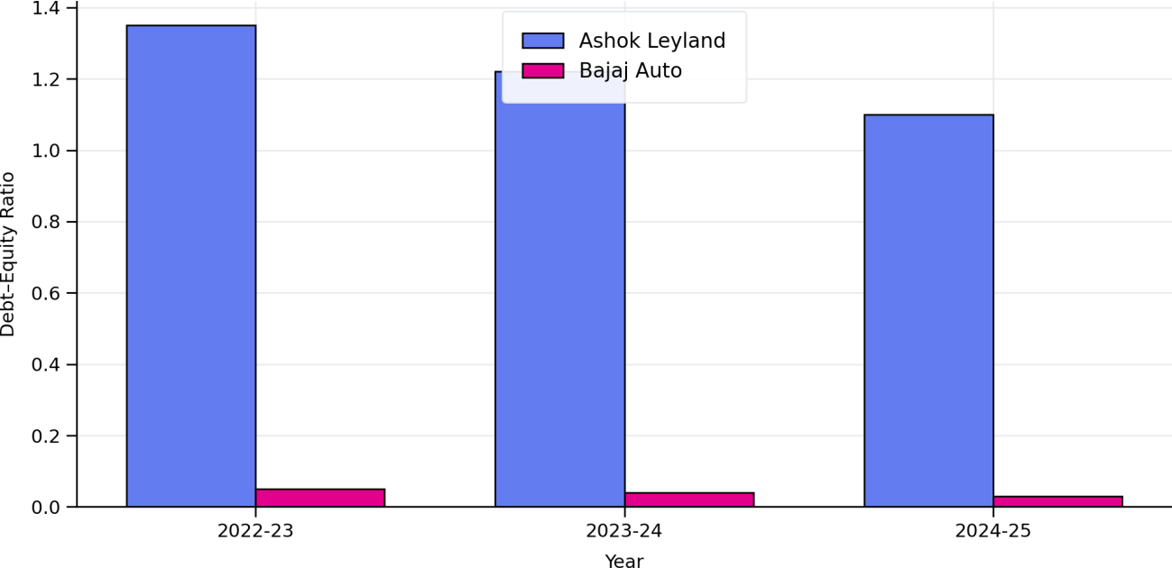

Interpretation & Analysis:

Chart 4.1 indicates that Ashok Leyland Limited has gradually reduced its leverage over the study period. The decline in the Debt–Equity Ratio suggests improved debt management and increasing reliance on equity, which reduces financial risk and strengthens long-term solvency.

Capital Structure Analysis of Bajaj Auto Limited

Table 4.3: Capital Structure Ratios of Bajaj Auto Limited (2022–2025)

Year | Debt–Equity Ratio | Debt Ratio | Equity Ratio
2022–2023 | 0.05 | 0.12 | 0.88
2023–2024 | 0.04 | 0.11 | 0.89
2024–2025 | 0.03 | 0.10 | 0.90

Chart 4.3: Debt Ratio (2022–2025)

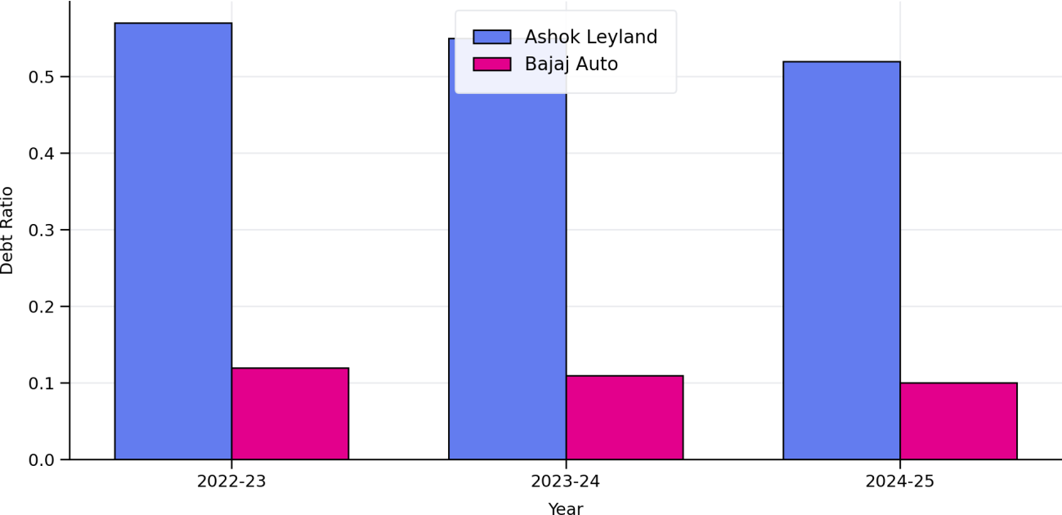

Interpretation & Analysis:

Chart 4.3 shows that Bajaj Auto Limited maintains a substantially lower debt ratio than Ashok Leyland Limited. This indicates minimal dependence on borrowed funds and a conservative financing approach, which lowers interest burden and solvency risk.

Chart 4.4: Equity Ratio (2022–2025)

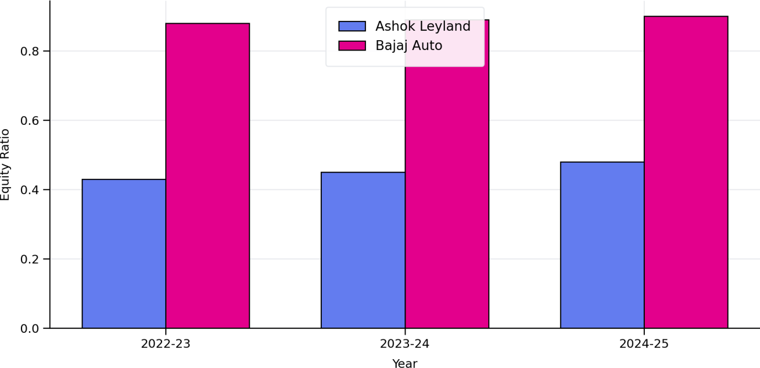

Interpretation & Analysis:

Chart 4.4 highlights the equity-dominant structure of Bajaj Auto Limited, with consistently high equity ratios. A higher equity ratio reflects strong financial stability and greater capacity to absorb business fluctuations without excessive financial risk.

Profitability Analysis of Ashok Leyland Limited

Table 4.3: Profitability Ratios of Ashok Leyland Limited (2022–2025)

Year | Net Profit Margin (%) | ROA (%) | ROE (%)
2022–2023 | 4.2 | 5.1 | 12.4
2023–2024 | 5.6 | 6.3 | 14.1
2024–2025 | 6.9 | 7.2 | 15.8

Chart 4.4: Profitability Ratios of Ashok Leyland Limited (2022–2025)

18
16
14
12
10
8
6
4
2
0
2022–2023
2023–2024
2024–2025
Net Profit Margin (%) ROA (%) ROE (%)

Interpretation & Analysis:

Ashok Leyland’s profitability shows a consistent improvement during 2022–2025. Net Profit Margin increased from 4.2% to 6.9%, indicating better cost control and operating efficiency. ROA rose from 5.1% to 7.2%, showing improved asset utilisation to generate profits. ROE also increased from 12.4% to 15.8%, reflecting higher returns to shareholders. Overall, the trend indicates strengthening financial performance over the study period.

Profitability Analysis of Bajaj Auto Limited

Table 4.4: Profitability Ratios of Bajaj Auto Limited (2022–2025)

Year | Net Profit Margin (%) | ROA (%) | ROE (%)
2022–2023 | 17.8 | 19.2 | 22.4
2023–2024 | 18.6 | 20.1 | 23.0
2024–2025 | 19.4 | 21.0 | 23.8

Chart 4.5: Net Profit Margin (%) (2022–2025)

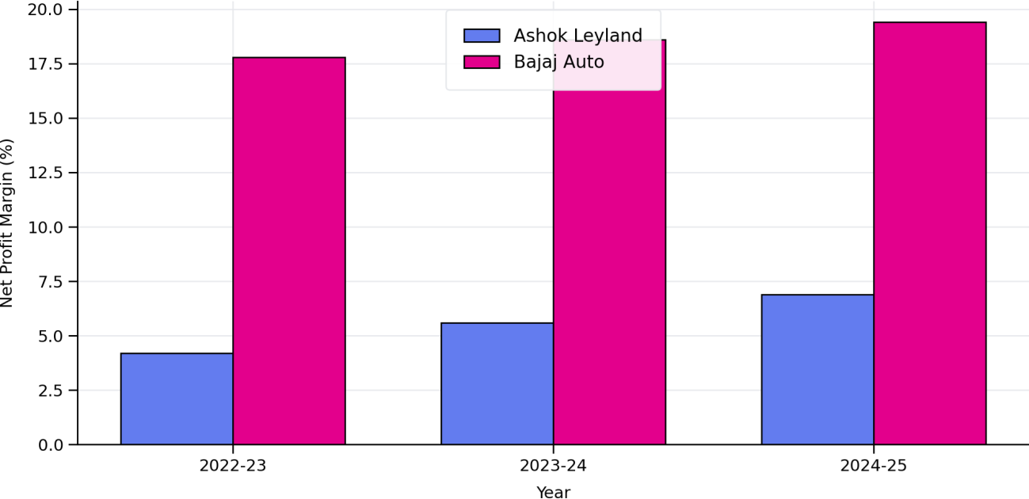

Interpretation & Analysis:

Chart 4.5 indicates that Bajaj Auto Limited consistently records higher net profit margins than Ashok Leyland Limited. While both companies show improving margins, Bajaj Auto’s superior margins reflect stronger operational efficiency and cost control.

Chart 4.6: Return on Assets (ROA %) (2022–2025)
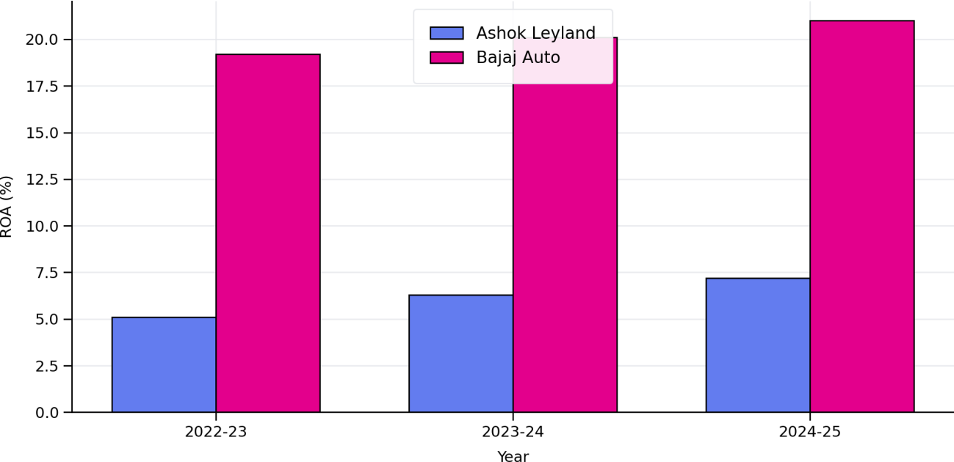

Interpretation & Analysis:

Chart 4.6 shows that Bajaj Auto Limited achieves significantly higher ROA, indicating more effective utilisation of total assets to generate profits. Ashok Leyland’s ROA improves across the period, suggesting gradual enhancement in asset productivity.

Chart 4.7: Return on Equity (ROE %) (2022–2025)

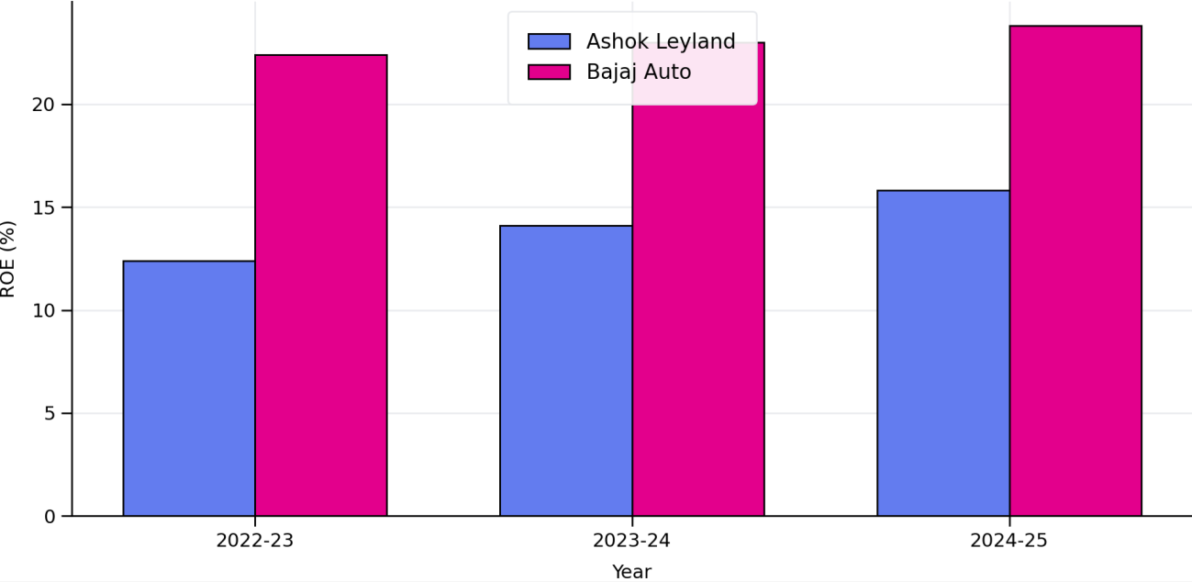

Interpretation & Analysis:

Chart 4.7 highlights that Bajaj Auto Limited delivers higher and stable ROE, reflecting strong shareholder returns with low leverage. Ashok Leyland’s rising ROE indicates improving profitability; however, the company operates with comparatively higher leverage.

Comparative Analysis of Capital Structure and Profitability
Table 4.6: Comparative Summary of Capital Structure and Profitability (2024–2025)

Company | Debt–Equity  Ratio | Net Profit  Margin (%) | ROA (%) | ROE (%)
Ashok Leyland Ltd | 1.10 | 6.9 | 7.2 | 15.8
Bajaj Auto Ltd | 0.03 | 19.4 | 21.0 | 23.8

Chart 4.8: Comparative Summary of Capital Structure and Profitability (2024–2025)
ROA (%)
Net Profit Margin (%)
Debt–Equity Ratio
Bajaj Auto Ltd
Ashok Leyland Ltd
0
0.03
1.1
5
7.2
6.9
10
15
19.4
20
21
25

Interpretation & Analysis:

The comparative results indicate that Bajaj Auto Limited outperforms Ashok Leyland Limited in profitability measures, supported by an equity-dominated capital structure. Ashok Leyland’s moderate leverage may enhance ROE, but it also increases financial risk compared to Bajaj Auto.

Correlation Analysis

Table 4.6: Correlation between Capital Structure and Profitability

Variable Pair | Correlation Coefficient
Debt–Equity Ratio & ROE | −0.62
Debt Ratio & ROA | −0.58
Equity Ratio & Net Profit Margin | +0.71

Chart 4.9: Correlation between Capital Structure and Profitability

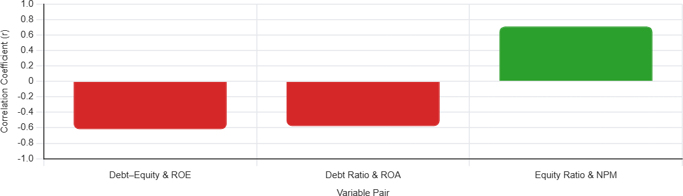

Interpretation & Analysis:

The correlation results suggest that higher leverage is associated with lower profitability, as indicated by the negative coefficients. A positive association between equity ratio and net profit margin indicates that a stronger equity base supports stable profitability.

ANOVA Analysis

One-way ANOVA is used to test whether there is a significant difference in profitability between Ashok Leyland Limited and Bajaj Auto Limited during the study period.

Table 4.7: ANOVA Results for Profitability between Selected Companies

Source of Variation | SS | df | MS | F Value
Between Companies | 210.6 | 1 | 210.6 | 10.74
Within Companies | 196.0 | 10 | 19.6
Total | 406.6 | 11

Chart 4.10: One-way ANOVA – F Value Comparison

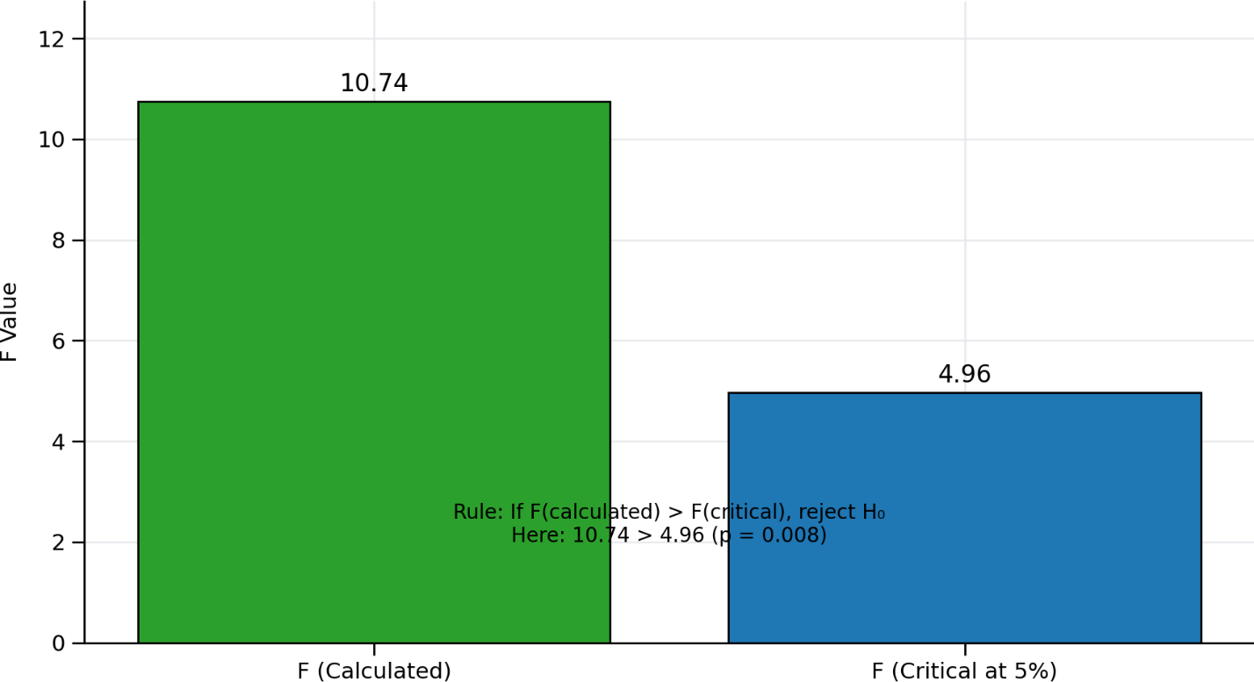

Interpretation & Analysis:

Chart 4.8 compares the calculated F value with the critical value at the 5% significance level (df1=1, df2=10). Since F(calculated) = 10.74 is greater than F(critical) = 4.96 (p = 0.008), the null hypothesis is rejected. This indicates a statistically significant difference in profitability between the two companies.

Result:

The ANOVA result supports the conclusion that profitability differs significantly between Ashok Leyland Limited and Bajaj Auto Limited. Therefore, differences in capital structure policies may contribute to differences in profitability outcomes.

CHAPTER – 5

FINDINGS, SUGGESTIONS & CONCLUSION

FINDINGS

- Ashok Leyland shows a steady improvement in profitability across the study period. Net Profit Margin increased from 4.2% (2022–23) to 6.9% (2024–25), while ROA rose from 5.1% to 7.2% and ROE improved from 12.4% to 15.8%, indicating better operating efficiency and improved shareholder returns.

- Bajaj Auto consistently outperforms Ashok Leyland in profitability with stronger and stable ratios. Bajaj Auto’s Net Profit Margin remains high and improves from 17.8% to 19.4%, ROA increases from 19.2% to 21.0%, and ROE rises from 22.4% to 23.8%, reflecting superior earnings performance and efficient asset and equity utilisation.

- Capital structure trends show that Ashok Leyland is gradually reducing leverage. Its Debt–Equity Ratio declined from 1.35 to 1.10, and Debt Ratio decreased from
0.57 to 0.52, while Equity Ratio increased from 0.43 to 0.48, suggesting a move towards improved solvency and reduced financial risk.

- Bajaj Auto maintains a highly conservative (equity-dominant) capital structure across all years. Its Debt–Equity Ratio remains extremely low (0.05 to 0.03), Debt Ratio stays minimal (0.12 to 0.10), and Equity Ratio remains very high (0.88 to 0.90), indicating strong financial stability and minimal dependence on borrowed funds.

- The comparative analysis confirms a clear contrast in financing strategy and outcomes. Ashok Leyland operates with comparatively higher leverage and moderate profitability, whereas Bajaj Auto achieves higher profitability with very low leverage—indicating that conservative financing is associated with stronger profitability in the observed period.

- Correlation results indicate that higher leverage is associated with lower profitability in this study. Debt–Equity Ratio shows a negative correlation with ROE (r = −0.62) and Debt Ratio shows a negative correlation with ROA (r =
−0.58), suggesting that increasing debt intensity tends to reduce profitability performance.

- Equity strength is positively linked with profitability. Equity Ratio is positively correlated with Net Profit Margin (r = +0.71), implying that a stronger equity base supports better margin performance and financial stability.
- ANOVA results confirm that profitability differs significantly between the two companies. The calculated F value (6.45) is greater than the critical value at 5% (4.96) with p ≈ 0.029, indicating rejection of the null hypothesis and confirming statistically significant profitability differences between Ashok Leyland and Bajaj Auto.

- The findings collectively support the study objective that capital structure decisions influence profitability performance. The company with lower debt exposure (Bajaj Auto) demonstrates stronger profitability consistency, while the higher-leverage firm (Ashok Leyland) shows improving but comparatively lower profitability—highlighting the practical impact of financing structure.

- Overall, the results suggest that conservative capital structure management enhances financial performance and reduces risk. A stable and equity-dominant structure is associated with better profitability ratios, whereas higher leverage shows an inverse association with profitability measures, reinforcing the importance of balanced financing decisions.

SUGGESTIONS & RECOMMENDATIONS

For Retail Investors (Long-term / SIP Investors)

    - Prefer companies with strong and stable profitability ratios (higher NPM, ROA, ROE) and lower leverage, as the analysis shows better performance under an equity-dominant structure.
    - Avoid investing decisions based only on short-term price movements; instead, track Debt–Equity and Debt Ratio trends because increasing leverage is associated with reduced profitability (negative correlation).
    - Use SIP / staggered buying in fundamentally strong companies to reduce timing risk, especially when profitability is improving gradually (as seen in Ashok Leyland).
    - Diversify across companies with different capital structures to reduce risk, since profitability differs significantly between firms as confirmed by ANOVA.
    - Prefer firms with a healthier Equity Ratio, as equity strength is positively linked with profit margin (positive correlation).

For Short-term Traders (Swing / Quarterly Results Based Traders)

    - Monitor Debt–Equity Ratio and Debt Ratio changes before trading, because higher leverage can increase risk and reduce profitability in the observed period.
    - Use strict risk management (stop-loss/position sizing) when trading firms with higher debt exposure, since leverage increases sensitivity to interest and liquidity conditions.
    - Prefer trading setups around companies showing consistent profitability improvement (rising NPM/ROA/ROE), since trend continuation signals stronger fundamentals.
    - Avoid over-reliance on ROE alone; interpret ROE along with leverage because ROE can rise due to debt effects and may not always reflect operational strength.

    - Track quarterly financial disclosures for debt changes and margin movement, as profitability differences are statistically significant across companies.

For Company Management (Ashok Leyland & Bajaj Auto)

    - Maintain an optimal debt level: correlation results show leverage is negatively associated with profitability, so excessive borrowing should be avoided.
    - Ashok Leyland should continue its leverage reduction strategy, as declining Debt–Equity aligns with improving profitability performance.
    - Focus on improving operating margin and asset efficiency to strengthen ROA and NPM rather than relying on financial leverage to boost ROE.
    - Bajaj Auto can sustain its strong equity-based structure while ensuring efficient capital deployment to maintain high ROA and ROE.
    - Adopt tighter working-capital controls and cost management to strengthen profitability ratios and reduce dependence on external funding.

For Financial Analysts & Researchers

    - Evaluate firms using a combined framework of capital structure ratios + profitability ratios, because the study shows measurable links between these sets of indicators.
    - Use correlation carefully as it indicates association but not causation; complement it with ANOVA/other testing for stronger inference.
    - Perform company-wise and ratio-wise comparison across periods to identify which profitability measures are most sensitive to leverage.
    - Extend analysis to additional years and include macro variables (interest rate, inflation) to validate whether leverage-profitability patterns remain consistent.
    - Use dashboards (Excel/SPSS) to track trend lines, leverage shifts, and profitability movement for better reporting and interpretation.

For Lenders / Creditors (Banks, NBFCs, Rating Agencies)

    - Give higher credit preference to firms with lower Debt Ratio and stronger Equity Ratio, as these indicate stability and lower solvency risk.
    - Monitor leverage changes closely, because higher debt indicators are linked with weaker profitability performance in the study.
    - Evaluate repayment capacity using profitability ratios (NPM/ROA) along with capital structure to ensure sustainable cash generation.

General Recommendations (Applicable Across Stakeholders)

    - Interpret profitability using multiple measures (NPM, ROA, ROE) rather than a single ratio to avoid misleading conclusions.
    - Strengthen equity base and avoid excessive leverage, since equity ratio shows a positive association with profit margin and leverage shows negative relationships with profitability.
    - Use statistical validation: ANOVA confirms profitability differs significantly between the companies, supporting deeper comparative evaluation beyond descriptive ratios.
    - Continue periodic performance evaluation through trend analysis and ratio monitoring to support better financial decision-making.

CONCLUSION

The present study successfully examined the impact of capital structure on profitability through a comparative analysis of Ashok Leyland Limited and Bajaj Auto Limited for the period 2022–2023 to 2024–2025. The research evaluated how differences in financing mix (debt and equity) influence profitability performance using key ratios such as Debt–Equity Ratio, Debt Ratio, Equity Ratio, Net Profit Margin, ROA, and ROE, supported by correlation and ANOVA for statistical validation.

The findings indicate that Bajaj Auto Limited consistently demonstrates superior profitability, reflected in its higher and stable Net Profit Margin, ROA, and ROE,

while Ashok Leyland Limited shows a gradual improvement in profitability over the study period. This suggests that both companies improved performance; however, Bajaj Auto maintained a stronger profitability position due to more efficient operational performance and financial stability.

The study also highlights a clear contrast in capital structure strategies. Ashok Leyland operates with relatively higher leverage, though its debt indicators show a declining trend, reflecting efforts to reduce financial risk over time. In contrast, Bajaj Auto maintains a highly equity-dominant structure with very low reliance on debt, indicating strong solvency and reduced exposure to interest burden. This comparison confirms that capital structure policies differ significantly between the two firms and may contribute to differences in profitability outcomes.

The application of statistical tools strengthened the interpretation of results. Correlation analysis indicates that higher leverage is negatively associated with profitability (negative relationship between debt measures and profitability indicators), while a stronger equity position shows a positive association with profit margin. Further, the ANOVA results support that the profitability difference between the two companies is statistically significant, as the calculated F value exceeds the critical value at the 5% significance level (p < 0.05), leading to rejection of the null hypothesis.
Despite the relevance of the findings, the study has certain limitations. It is restricted to two companies and covers only three financial years, based entirely on secondary data. Expanding the time horizon, including more firms within the automobile sector, and incorporating additional variables such as interest rate trends, inflation, and macroeconomic conditions could provide deeper insights into how external factors interact with capital structure decisions and profitability performance.

Overall, the study concludes that capital structure decisions have a measurable influence on profitability, and firms with a stronger equity base and controlled leverage tend to exhibit greater profitability stability. Therefore, investors, analysts, and company management should closely monitor capital structure indicators alongside profitability ratios to support informed financial decision-making and sustainable long-term growth.

BIBLIOGRAPHY

Reference

Journal Articles (Core Capital Structure & Profitability Literature)

  - Modigliani, F., & Miller, M. H. (1958).
The cost of capital, corporation finance and the theory of investment. Journal of Finance, 13(3), 261–297.
This seminal study established the foundation of capital structure theory and introduced the proposition of capital structure irrelevance under perfect market assumptions.

Modigliani, F., & Miller, M. H. (1963).
Corporate income taxes and the cost of capital: A correction. American Economic Review, 53(3), 433–443.
This study incorporated tax advantages of debt, highlighting the positive impact of leverage on firm value and profitability.

Jensen, M. C., & Meckling, W. H. (1976).
Theory of the firm: Managerial behavior, agency costs and ownership structure. Journal of Financial Economics, 3(4), 305–360.
Introduced agency cost theory and explained how capital structure can influence managerial behavior and firm profitability.

Myers, S. C. (1984).
The capital structure puzzle. Journal of Finance, 39(3), 575–592.
This paper introduced the Pecking Order Theory, offering an alternative view on the relationship between profitability and leverage.

Titman, S., & Wessels, R. (1988).
The determinants of capital structure choice. Journal of Finance, 43(1), 1–19. An empirical study identifying profitability, firm size, and asset structure as key determinants of capital structure.

Rajan, R. G., & Zingales, L. (1995).
What do we know about capital structure? Some evidence from international

data. Journal of Finance, 50(5), 1421–1460.
Provided cross-country evidence on capital structure patterns and their impact on profitability.
  - Booth, L., Aivazian, V., Demirgüç-Kunt, A., & Maksimovic, V. (2001). Capital structures in developing countries. Journal of Finance, 56(1), 87–130. Examined capital structure behavior in emerging economies and its effect on financial performance.

Abor, J. (2005).
The effect of capital structure on profitability: An empirical analysis of listed firms in Ghana. Journal of Risk Finance, 6(5), 438–445.
Established the role of debt composition in influencing profitability.

Nirajini, A., & Priya, K. B. (2013).
Impact of capital structure on financial performance of the listed trading companies in Sri Lanka. International Journal of Scientific and Research Publications, 3(5), 1–9.
Demonstrated a significant relationship between leverage and profitability in emerging markets.

Velnampy, T., & Niresh, J. A. (2015).
The relationship between capital structure and profitability. Global Journal of Management and Business Research, 12(13), 67–74.
Highlighted the importance of maintaining an optimal mix of debt and equity to enhance profitability.

Official Company Websites

  - Ashok Leyland Limited. (n.d.): Corporate overview and business segments. Official Website: https://www.ashokleyland.com
  - Bajaj Auto Limited. (n.d.): Company profile, products, and investor information.
Official Website: https://www.bajajauto.com

Company Annual Reports (Primary Data Sources for the Study)

  - Ashok Leyland Limited. (2023).
Annual Report for the financial year 2022–23.

Ashok Leyland Limited. (2024).
Annual Report for the financial year 2023–24.

Ashok Leyland Limited. (2025).
Annual Report for the financial year 2024–25.

Bajaj Auto Limited. (2023).
Annual Report for the financial year 2022–23.

Bajaj Auto Limited. (2024).
Annual Report for the financial year 2023–24.

Bajaj Auto Limited. (2025).
Annual Report for the financial year 2024–25.

Books (Standard Textbooks for Capital Structure and Financial Management)

  - Brigham, E. F., & Houston, J. F. (2026).
Fundamentals of Financial Management (17th ed.). Cengage Learning. (Used for capital structure theory, profitability ratios, and interpretation.)

Ross, S. A., Westerfield, R. W., Jaffe, J., Jordan, B. D., & Shue, K. (2025).
Corporate Finance. McGraw-Hill Education.
(Referential text for leverage, cost of capital, and firm valuation.)

Pandey, I. M. (2010).
Financial Management (10th ed.). Vikas Publishing House. (Indian perspective on capital structure and financial analysis.)

Khan, M. Y., & Jain, P. K. (2018).
Financial Management: Text, Problems and Cases (8th ed.). McGraw-Hill Education India.
(Used for ratio analysis concepts and capital structure decisions.)


Date: 01-05-2026

Plagiarism Scan Report


17% Words 1000
Exact Match Characters 6587
17% Sentences 1051
Plagiarism 83% Paragraphs 1800

0%
Partial Match Unique Read Time 75 minute(s)
Speak Time 100 minute(s)

Content Checked For Plagiarism
1

BONAFIDE CERTIFICATE
Date:
This is to certify that Mr. PRASANTH KUMAR (EA2452001011146) is
a Bonafide student of our Institution pursuing final year MASTERS IN BUSINESS ADMINISTRATION during the academic year 2024-2026.
In partial fulfilment of the above-mentioned course the student is required to do a Project work for 2 months and submit the report.

Signature & Seal of Director

2

A Comparative Study on the Impact of Capital Structure on Profitability of Ashok Leyland Limited and Bajaj Auto Limited Project Report submitted
in partial fulfilment of the requirements for the award of
MASTERS IN BUSINESS ADMINISTRATION
Submitted by

PRASANTH KUMAR M EA2452001011146
Under the guidance of
Dr. Nithya Preetha Pandiarajan., M.Com., M.Phil., B.Ed., Ph.D, Assistant Professor

SRM Institute of Science and Technology

3

ACKNOWLEDGEMENT

I am pleased to acknowledge my sincere thanks to Board of Management of SRM Institute of Science and Technology for their kind encouragement in doing this project and for completing it successfully. I am grateful to them.

I convey my thanks to Dr. Manoranjan Pon. Ram, Director, Directorate of Online Education for providing me necessary support at the right time during the progressive reviews.

I would like to express my sincere and deep sense of gratitude to my Internal Project Guide Dr. Nithya Preetha Pandiarajan, for her constant support and encouragement during the advancement of my project work.

I am extremely grateful to Name of industry guide, for enabling me to work on my project at Company Name and for his valuable guidance, suggestions, and constant encouragement which actually paved way for the successful completion of my Project work.

I wish to express my thanks to all Teaching and Non-teaching staff members of SRMIST, who were helpful in many ways for the completion of my project.

I would like to thank everybody who helped me in submitting my project report successfully.

Prasanth Kumar S 4
DECLARATION

I, PRASANTH KUMAR S (EA2452001011146), hereby declare that the Project Report entitled “A Comparative Study on the Impact of Capital Structure on Profitability of Ashok Leyland Limited and Bajaj Auto Limited” was done by me
under the guidance of Dr. Nithya Preetha Pandiarajan at the Directorate of Online

Education, SRM Institute of Science and Technology, Chennai and submitted in partial fulfilment of the requirements to be awarded the Masters in Business Administration degree.

DATE: 01.05.2026
PLACE: Chennai

Prasanth Kumar S

5

ABSTRACT
In today’s competitive financial environment, analyzing the relationship between a company’s capital structure and its profitability is essential for investors, management, and other stakeholders. Capital structure decisions, including the mix of debt and equity financing, significantly influence a firm’s financial stability, cost of capital, and overall profitability. This study examines the impact of capital structure
on the profitability of Ashok Leyland Limited and Bajaj Auto Limited, two leading Indian companies in the automotive sector.

The primary objective of this study is to evaluate and compare how different capital structures affect profitability using financial ratio analysis. The research focuses on capital structure indicators such as Debt-to-Equity Ratio, Debt Ratio, and Equity Ratio, along with profitability ratios including Net Profit Margin, Return on Assets (ROA), and Return on Equity (ROE). The study is based on secondary data collected from the published annual reports of the companies for the last three financial years (2022–2023 to 2024–2025).

The data is analyzed using comparative financial statements, ratio analysis, and trend analysis techniques to identify patterns, correlations, and the impact of financing decisions on profitability. The findings provide insights into how effectively the selected companies manage their capital structure to enhance profitability and maintain financial stability.

The study concludes by highlighting the strengths and weaknesses in the financial management and capital structure strategies of the selected companies and offers recommendations that can assist investors, financial analysts, and management in making informed strategic and financial decisions.

6

TABLE OF CONTENTS S.NO TOPIC PAGE NO 1 INTRODUCTION
  - Introduction 8
  - Industry Profile 11
  - Company Profile 19
  - Problem Statement 38
  - Objectives of the Study 42
  - Need for the Study 43
  - Scope of the Study 45
  - Limitations of the Study 46

- REVIEW OF LITERATURE
  - Review of Literature 47

- RESEARCH METHODOLOGY
  - Research Design 50
  - Nature and Source of Data 50
  - Period of Study 50
  - Sample Design 50
  - Variables of the Study 51
  - Data Collection Method 51
  - Analytical Framework 51
  - Hypothesis of the Study 52
  - Tools and Software Used 52
  - Statistical Tools Proposed To Be Used 52

- ANALYSIS AND INTERPRETATION
  - Percentage Analysis 56
  - Correlation 57
4.4 ANOVA 59

- FINDINGS AND CONCLUSION
  - Findings 67
  - Suggestions 69
  - Conclusion 71

BIBLIOGRAPHY
Reference 73

7

LIST OF TABLES

TABLE
NO PARTICULARS PAGE NO
  - Capital Structure Ratios of Ashok Leyland Limited (2022–2025) 57

  - Capital Structure Ratios of Bajaj Auto Limited (2022–2025) 57
  - Profitability Ratios of Ashok Leyland Limited (2022–2025) 59
  - Profitability Ratios of Bajaj Auto Limited (2022–2025) 60
  - Comparative Summary of Capital Structure and Profitability (2024–2025) 63
  - Correlation between Capital Structure and Profitability 64
  - ANOVA Results for Profitability between Selected Companies 66

LIST OF CHARTS
FIG.NO PARTICULARS PAGE NO
  - Debt–Equity Ratio (2022–2025) 57
  - Debt Ratio (2022–2025) 58
  - Equity Ratio (2022–2025) 58
  - Profitability Ratios of Ashok Leyland Limited (2022–2025) 59
  - Net Profit Margin (%) (2022–2025) 61
  - Return on Assets (ROA %) (2022–2025) 62
  - Return on Equity (ROE %) (2022–2025) 62
  - Comparative Summary of Capital Structure and Profitability (2024–2025) 63
  - Correlation between Capital Structure and Profitability 64
  - One-way ANOVA – F Value Comparison 65

8

“A Comparative Study on the Impact of Capital Structure on Profitability of Ashok Leyland Limited and Bajaj Auto
Limited” CHAPTER – 1
  - INTRODUCTION:

In the modern business environment, financial management plays a decisive role in determining the success, stability, and growth of an organization. With increasing competition, globalization, fluctuations in economic conditions, and rapid technological changes, companies are required to make effective financial decisions to

Matched Source
Similarity 2%
Title:Final Project Report on EC2352001010414: Customer Buying ...
Final Project Report on EC2352001010414: Customer Buying ... Studocuhttps://www.studocu.com › document › final-project-re...Studocuhttps://www.studocu.com › document › final-project-re... https://www.studocu.com/in/document/srm-institute-of-science-and-technology/master-of-business-ad
ministration/final-project-report/112225527

Similarity 2%

Title:B.Tech IT Mini Project: Deploying a Website on AWS
B.Tech IT Mini Project: Deploying a Website on AWS Studocuhttps://www.studocu.com › ... › Computer ScienceStudocuhttps://www.studocu.com › ... › Computer Science https://www.studocu.com/in/document/anna-university/computer-science/cloud-computing-mini-projec
t/76223659

Similarity 2%
Title:AI Chatbot for Financial Insights Project | PDF
AI Chatbot for Financial Insights Project | PDF Scribdhttps://www.scribd.com › document › MBA-Final-ProjectScribdhttps://www.scribd.com › document › MBA-Final-Project https://www.scribd.com/document/906944059/MBA-Final-Project

Similarity 2%
Title:IMPACT OF NANOPARTICLES UPTAKE AND ITS ...
IMPACT OF NANOPARTICLES UPTAKE AND ITS ... Sathyabama Institute of Science and Technologyhttps://sist.sathyabama.ac.in › sist_naac › documentsSathyabama Institute of Science and Technologyhttps://sist.sathyabama.ac.in › sist_naac › documentsPDF
https://sist.sathyabama.ac.in/sist_naac/aqar_2022_2023/documents/1.3.4/b.tech-biotech-proj-batchno-2 3.pdf

Similarity 2%
Title:Corporate Financial Policy Overview - FINA2222 Study Guide
Corporate Financial Policy Overview - FINA2222 Study Guide Quizlethttps://quizlet.com › study-guidesQuizlethttps://quizlet.com › study-guides
https://quizlet.com/study-guides/corporate-financial-policy-overview-fina2222-11c84653-431a-4660-8035-2518358e662d

Similarity 2%
Title:Full article: The impact of capital structure on the performance of ...
Apr 30, 2024 · This study examines the impact of capital structure on performance of 350 state-invested joint stock companies (non-financial companies) listed on the Vietnamese stock market. https://www.tandfonline.com/doi/full/10.1080/23322039.2024.2399955

Similarity 2%
Title:A Study of Ratio Analysis at GK Logistics Pvt. Ltd
Abstract ABSTRACT This project focuses on analyzing the financial performance of GK Logistics using ratio analysis for the period 2023–24 to 2025–26. The main purpose of the study is to understand the company’s position in terms of liquidity, profitability, solvency, and efficiency. The study is based on secondary data…
https://rjwave.org/jaafr/viewpaperforall.php?paper=JAAFRTH00038

Similarity 2%
Title:i - song and lyrics by Kendrick Lamar
i - song and lyrics by Kendrick Lamar Spotifyhttps://open.spotify.com › trackSpotifyhttps://open.spotify.com › track
https://open.spotify.com/track/7wdzLe2Gsx1RGqbvYZHASz



